|  |
| --- |
| HND |
| D:\Myint Myat Kaung\2nd year 1st sem Assignment\Untitled-1 copy.PNG**Unit 14: Business Intelligence** |
| ***Business Process Support Mechanisms***  **May Thet Htar Aung**  Batch –67  2nd year,Second Semester  Assignment  **Start Date : 20.11.2022**  **End Date : 9.12.2022** |



Info Myanmar University

Table of Contents

LO 1: Discuss business processes and the mechanisms used to support business decision making. 4

P1. Examine, using examples, the terms “business process” and “supporting processes” with examples. 4

Introduction 4

Business Process 4

Online Electronic Sale and Services System For Sunny organization 6

Business Process and Supporting Processes For Sunny organization 6

The business model for Sunny organization business process 7

M1. Discuss the differentiation between structured, unstructured and semi-structured data within your organization using a comprehensive table. 7

Big Data 7

Structured Data 8

Unstructured Data 10

Semi-Structured Data 11

The differentiation between structured, unstructured and semi-structured data within Sunny organization using a comprehensive table 13

LO 2: Compare the tools and technologies associated with business intelligence functionality. 17

P2. Compare the types of support available for business decision-making at different levels within the organization 17

Business intelligence decisions 17

Strategic decisions 17

Tactical Decisions 17

Operational decisions 18

M2.Justify, with specific examples, the key features of business intelligence functionality 18

Business Intelligence Functionality 18

The key features of business intelligence functionality 19

LO 3: Demonstrate the use of business intelligence tools and technologies 24

P3. Determine, with examples, what business intelligence is and the tools and techniques associated with it. 24

ETL 25

Data Wearhouse 29

Data Mining 30

OLAP 33

P4.Design a business intelligence tool, application or interface that can perform a specific task to support problem-solving or decision-making at an advanced level. 39

M3. Customize the design to ensure that it is user-friendly and has a functional interface. 43

Pie Chart of the Total Sale By Year for Strategic Level 43

Area Chart of the Number of service ID by product code for Strategic Level 46

Cluster column Chart of the Number of Order By Year for Strategic Level 48

LO 4: Discuss the impact of business intelligence tools and technologies for effective decision-making purposes and the legal/regulatory context in which they are used. 54

P.5 Discuss how business intelligence tools can contribute to the effective decision-making. 54

How Business intelligence tools can contribute to effective decision-making 54

P6.Explore the legal issues involved in the secure exploitation of business intelligence tools. 56

M4.Conduct the research to identify the specific examples of organizations that have used business intelligence tools to enhance or improve operations. 58

Real-World Examples of Business Intelligence at Work 58

Lotte.com: BI Increases Company Revenue 58

Reddit 59

Coca-Cola Bottling Company maximized operational efficiency 60

References 62

# LO 1: Discuss business processes and the mechanisms used to support business decision making.

## P1. Examine, using examples, the terms “business process” and “supporting processes” with examples.

* Describe your business process and supporting processes from the current business strategies.
* Produce the business model for your current business process.

### Introduction

In the current world, gathering and analyzing as much information as we can is necessary to make an organization completely functional. Every firm in the world is collecting more data every day as a result. That information indicates that business intelligence and business analyst talents are highly sought after in the employment market today. The easy-to-use sophisticated application for business intelligence/analytics known as Microsoft Power BI is one of the hottest job requirements on the market. Corporation intelligence is used for many different things, including quantitative analysis, reporting, planning, and data exchange. It becomes one of the essential elements for a business to grow better.

I work as a junior business analyst for a Sunny organization company that leads its industry. The CEO of the firm where I work has talked about streamlining corporate operations and coming up with a better solution for the company. I want to position his business to gain more client contentment, better client service, a stronger competitive edge, various sales and profit reports to managers, quicker purchasing procedures for both a vendor and a business, and predictive analytics of the industry trend. I was tasked with locating a business intelligence solution that might at least somewhat enhance one of their existing business processes. I must evaluate the present process, put together a team, and oversee the project in order to offer this solution.

### Business Process

A business process is a collection of actions that, either directly or indirectly, aid in the delivery of goods and services to customers. Every business revolves on its processes. How well you have handled your company operations affects both the short- and long-term growth of the organization and the daily productivity of employees. The amount of work you do will significantly decrease once you are aware of your business processes and are able to put them into action. There have three types of business processes.

* Operating Processes
* Managing Processes
* Supporting Processes

**Operational Processes**

These are the company's primary operations. The core values, vision, and goal of the company are intimately tied to these procedures. They are sometimes referred to as fundamental processes. These procedures require additional care because they are the company's main sources of income. It's crucial to close the gaps and make the required adjustments to these procedures. Your firm will flourish as a result of the assessment of these procedures after it is finished. For instance, the ordering, preparation, and serving of meals would be the three steps in the operation of a McDonald's restaurant.

**Managing Processes**

Managing processes refers to the procedures used to plan, arrange, coordinate, and oversee all corporate operations. These procedures have objectives in mind. It entails encouraging and assisting your team in reaching their goals. These procedures also aid in establishing a course for your company's future expansion. These operations include regulating routine duties, instructing staff on how to do jobs well, introducing a new product, etc. For instance, top-level management, managers, and CEOs typically participate in management processes.

**Supporting Processes**

These are the procedures that have no bearing on how a service or product is delivered to a consumer. However, they aid the company in developing a setting where the core operations may operate more effectively. The term "supportive process" derives from this. These are the procedures that fall within the purview of the accounting, human resources, and any other departments that assist in carrying out the core operations of the company. E.g., Recruiting new workers is a supporting activity that aids in corporate growth.

### Online Electronic Sale and Services System For Sunny organization

The main business processes of Sunny organization is Sale devices and Services Devices systems. As an online electronic store, we usually sell popular electronic devices and branded devices in our organization. When it comes to providing service, we only provide services under warranty for devices purchased from sunny organizations. The main processes of Sunny organization are order to cash process and service process. And then the supporting processes are finical process, shipping process and store product process.

### Business Process and Supporting Processes For Sunny organization

Whenever the customer wants to order from “SUNNY” electronic device online shop, there is step by step process called order to cash. This process starts when clerk from sale department receive a form from a customer. So the clerk will admit these forms. And then they will divide these forms into two piles, purchase order forms and service forms for the product. So, if that was the purchase order , that will arrive to the clerk of the warehouse department. So that this department will check that the order is only confirmed if the product is in stock. And then the clerk of the sale department will send the reject order form to the customer. If the product is in stock, it is retrieved from the warehouse before confirming the order. Further, if the order is confirmed, the shipment address is received and the requested product is shipped from the warehouse department while the invoice is emitted from the sale department and the payment is received from finical department. Afterwards, the order is achieved and the process complete. If the product is not in stock, the clerk of the warehouse will ask to the other resource for this device. If this product can instock in a short time, we will confirm the order and will do the confirmation process. If the product can’t instock in a short time, we will send the rejection form to the customer.

If this form is a service form from the customer, we should give the information to the service department. If the device is from our organization, we should check the warranty of this device. If there have warranty, we should return the new one to the customer. If not ,we should give the rejected information form to the customer.

### The business model for Sunny organization business process



Fig() The Business process model of Online Electronic sale and service system for Sunny organization

# M1. Discuss the differentiation between structured, unstructured and semi-structured data within your organization using a comprehensive table.

Discuss structured, unstructured and semi-structured data in your organization

with examples.

### Big Data

Big Data, a term that has lately gained popularity, is now understood to refer to a sizeable volume of data that cannot be stored or handled using standard data storage or processing tools. Due to the enormous volume of data generated by both human and machine activity, the data are so complicated and vast that neither people nor a relational database can analyze them. However, when properly analyzed using contemporary techniques, these vast amounts of data provide firms significant insights that aid them in improving their operations by taking wise decisions. There are three types of big data.

* Structured Data
* Unstructured Data
* Semi-Structured Data

### Structured Data

Big data that has a predetermined length and format is often referred to as structured data. Structured data has features that can be addressed for efficient analysis. Data that is well-structured and arranged, either through tables or another method, and that is simple to use. It relates to any data that may be kept in a table with rows and columns in a SQL database. Information that has been prepared and translated into a clear data model is referred to as structured data. The unstructured data is mapped into pre-designed fields so that it may be readily retrieved and read by SQL. Structured data is perfectly exemplified by SQL relational databases, which include tables with rows and columns.

Since it reduces data redundancy, the relational model of this data format makes good use of memory. Structured data, however, is both less adaptable and more interdependent as a result. Let's look at some additional instances of structured data right now.

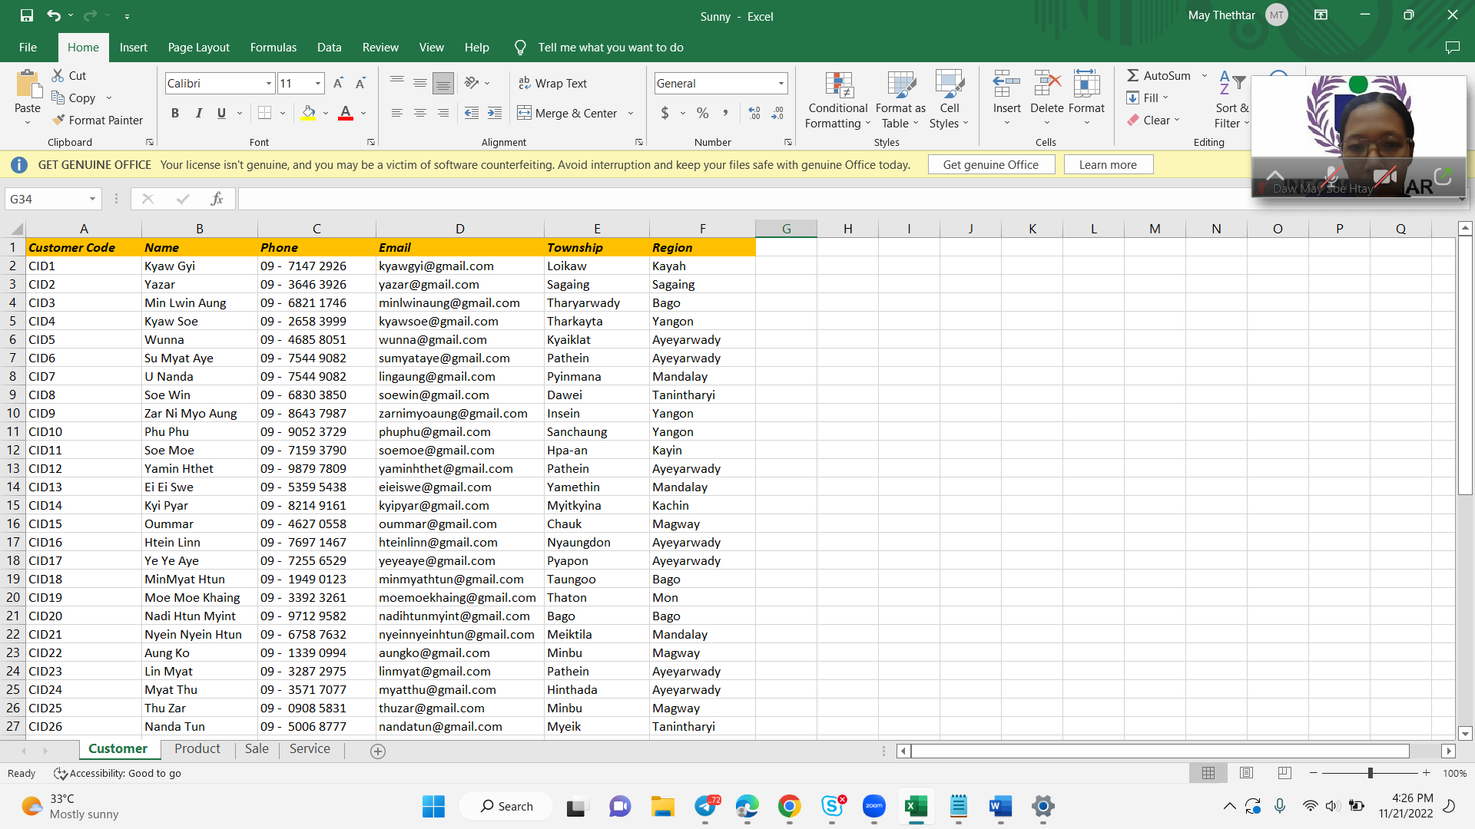

The above figure shows the customer data from the sunny organization. These data are also structured data and consists of customer code, customer name, Phone, Email, Township and Region. In my business processes, most of the data are structured data. Because we can see do the relational for each data. And then these data reduce the space complexity and time complexity and so on. For the users, these data can easily to understand and easily to keep perfectly and tidy.

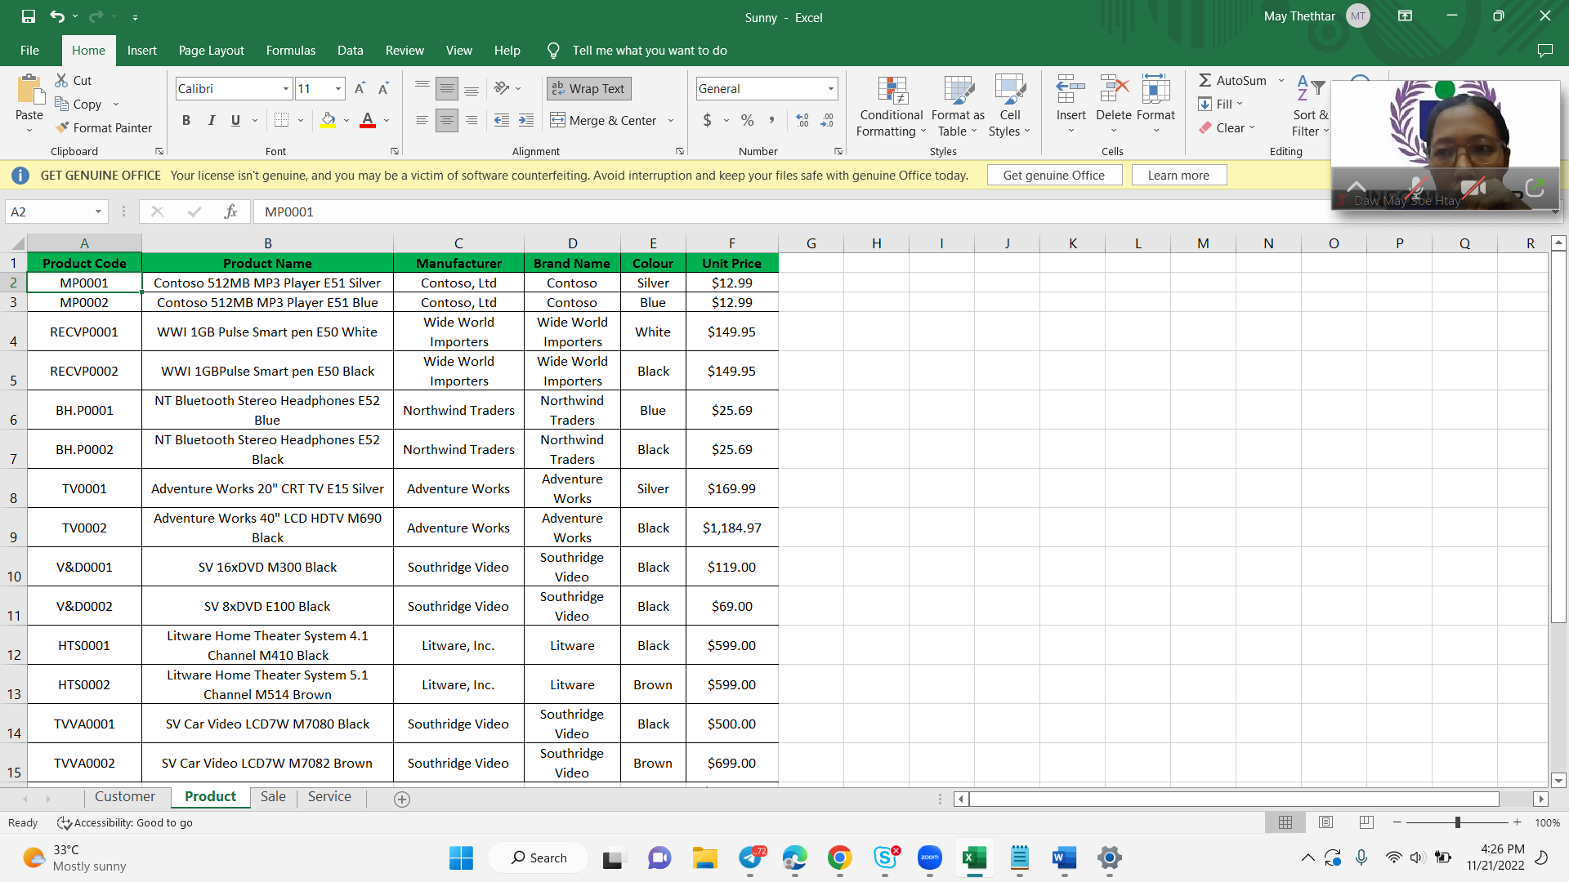

The above figure shows the Product data from the sunny organization. These data are also structured data and consists of Product Code, Name, Manufacture, Brand Name , Color and Unit Price.

### Unstructured Data

Unstructured data is described as information that is present in its purest form. Due to its intricate organization and structure, this material is challenging to analyze. Unstructured data management may arrange data in a data store in a logical, preset way using information from a variety of sources, such as social network postings, conversations, satellite images, IoT sensor data, emails, and presentations. Structured data, on the other hand, refers to data that adheres to predetermined data models and is simple to analyze.

Unstructured data is data that is not predefined in terms of organization or lacks a predefined data model, making it unsuitable for a common relational database. Text and multimedia are frequently present in unstructured data files. example. There are many different types of business papers, including word processing documents, PDFs, PowerPoint presentations, Text Media, Web pages, and emails.

Some of my unstructured data in my organization is the images and emails from my customers. In my organization have some images and text file for each product to upload on the site. These data keeps into the Sunny databases. These data are mainly attractive for customer’s attention. And then some of the customer’s feedbacks , we accept from the email. So those types of data keep as an unstructured data in my organization. Thus, unstructured data helps you improve customer experience. Some of the customer give feedback for the product on the social media , these data are also unstructured data. But these unstructured data are complexity so we need give much time to understand and to do as a useable data. These following data are my unstructured data for my organization.

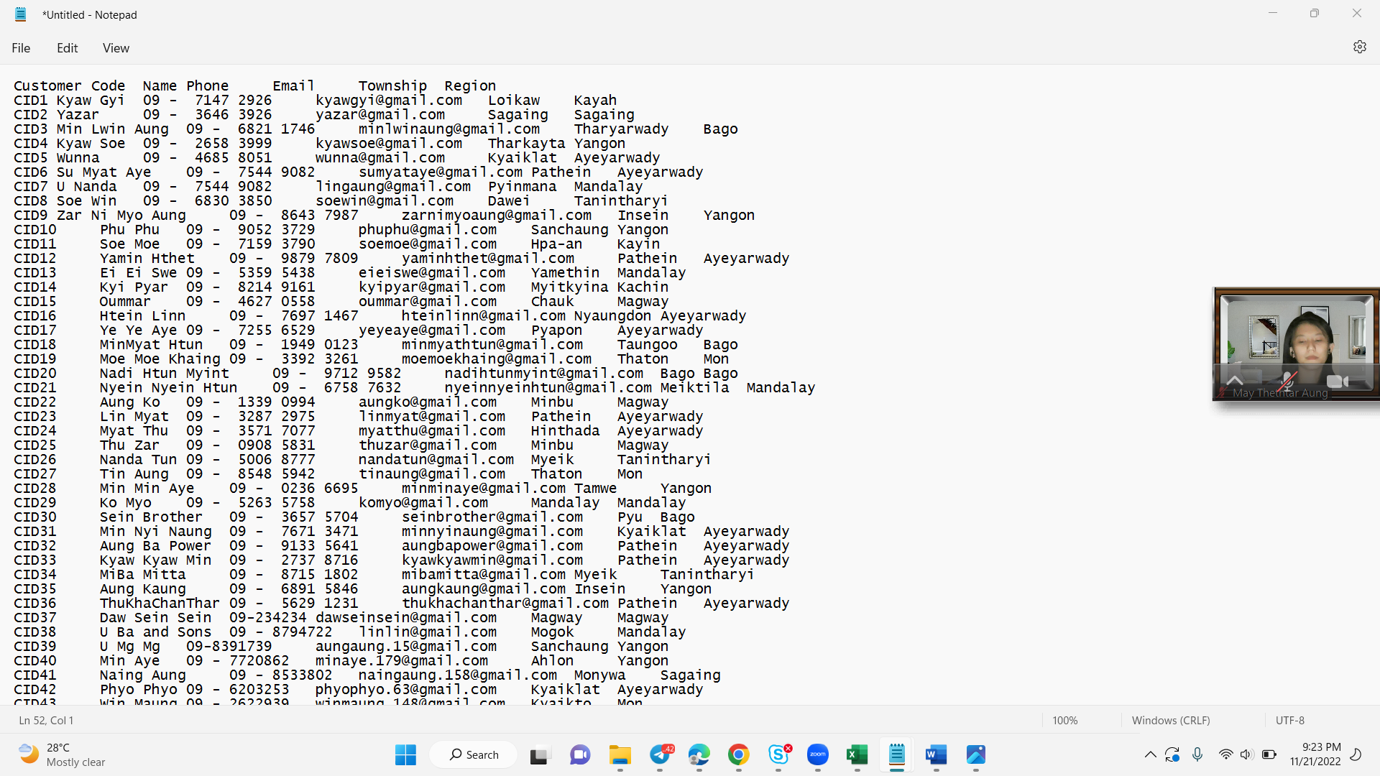

Fig(3.) Unstructured Data

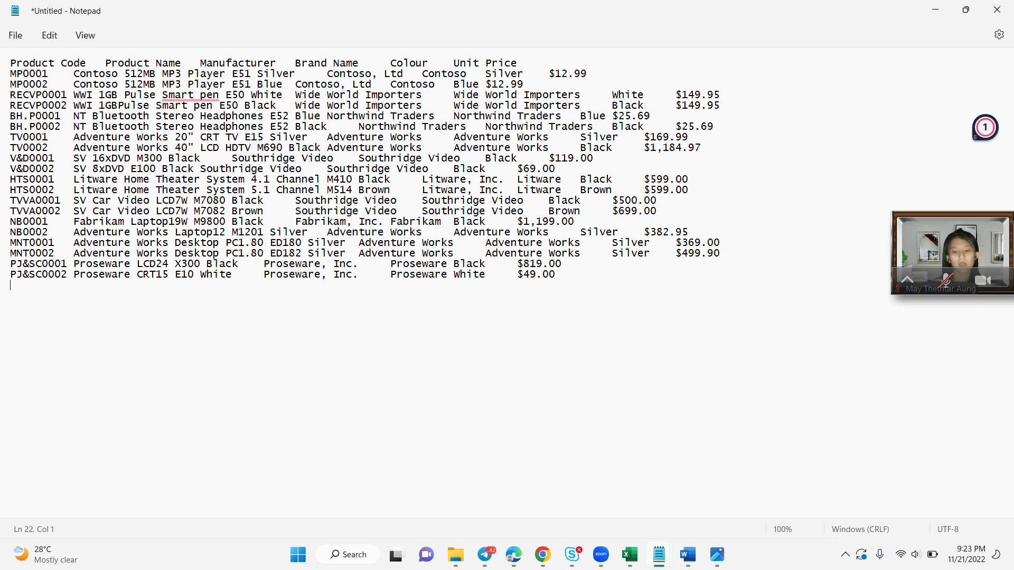

Fig(3.) Unstructured Data

### Semi-Structured Data

Both organized and unstructured data sets are possible; semi-structured data, also known as partially structured data, is another category in between. Semi-structured data is a subset of data that possesses a few recurrent and distinguishable traits. It is not constrained by a strict structure like that required for relational databases. Semi-structured data is made more manageable by organizational features like metadata or semantic tags, but it still has some unpredictability and inconsistency. In essence, semi-structured data is unordered structured data. It is data that is not stored in a relational database but has organizational characteristics that facilitate analysis. The example of semi-structured data are XML,JSON document, csvfile and webpages.

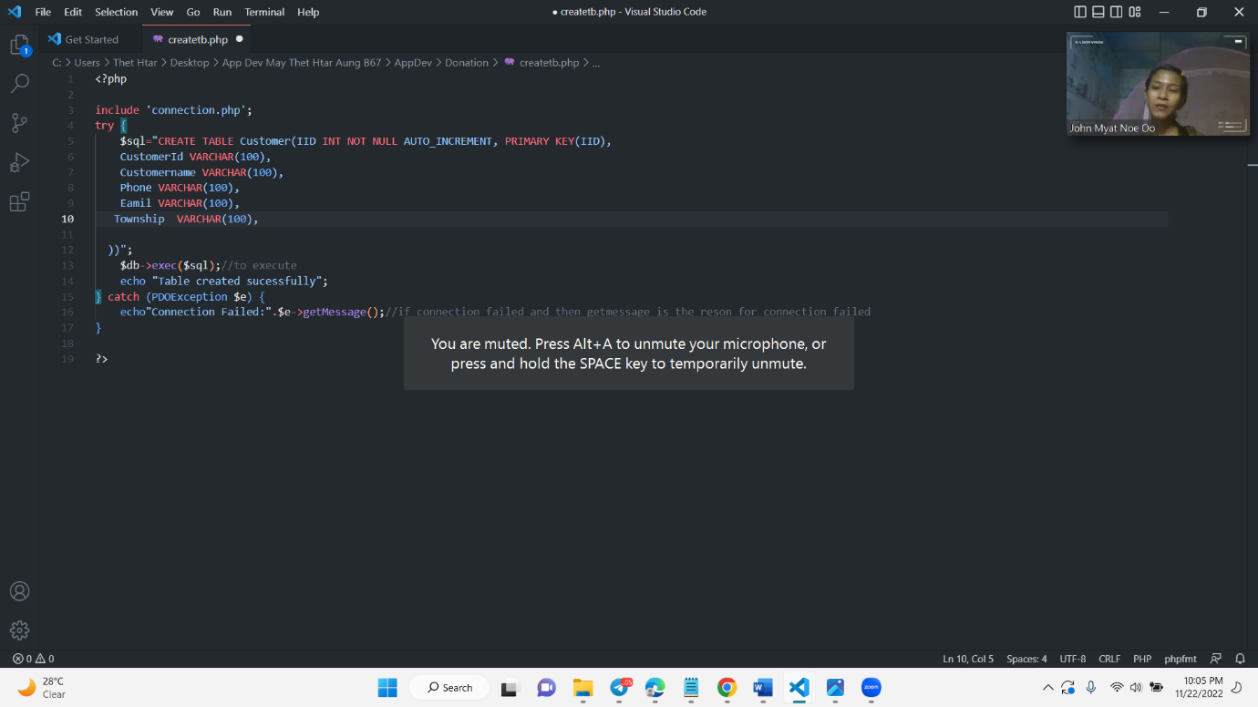

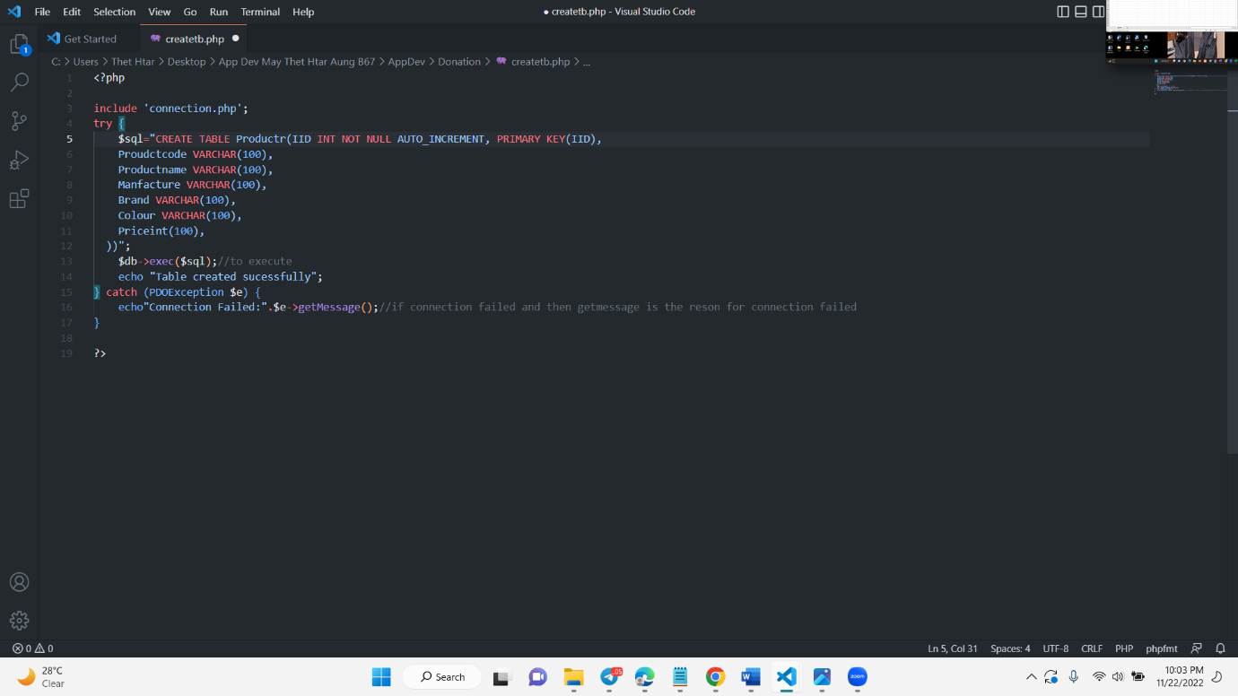

I did the online electronic sale and service system of E-commerce sites for Sunny organization. So I did the E-commerce site by using PHP and MySQL for the backend site. And then there have HTML coding for the front-end design and the content for the product and organization . So, these are the semi-structured data for my sunny organization. These data are also important for our organization. The main foundation for our organization is the online sale and service businesses. So these data are Essential data to continue the business processes. These semi data structured to understand , those people and users might be from the IT environments. The upper photo are the product and customer table of this site.

### The differentiation between structured, unstructured and semi-structured data within Sunny organization using a comprehensive table

|  |  |  |  |
| --- | --- | --- | --- |
| **Features** | **Structured Data** | **Unstructured Data** | **Semi-Structured Data** |
| Meaning | Structured data means the data have the schema. data should be structured format like tabular rows and columns format. | Unstructured data means the data should not have any schema like videos,images,logs etc… | Semi-structured means some raw data like JSON and XML data. |
| Format Types | Relational Database  Spreadsheet | Images  Video files  Text  Audio file formats  Emails | JSON files  XML  HTML web pages  CSV files |
| Mapping | Data is mapped by Relational Database | Data is mapped on the basis of binary and simple character | Data is mapped with XML/RDF |
| Performance | Guarantees highest performance with structure query | Only Textual query is executable | Only allows anonymous queries |
| Organized | Highly Organized data | Unorganized data | Partially organized data |
| Advantages | -Easily understood by machine learning algorithms- The organized and detailed format of structured data makes it easy to manipulate and pull specific data.  -Easily understood and used by business users- Structured data can be understood and used by an average business user who has an understand of the related data topic.  -Offers more accessibility to tools- Structured data was once the only form of data available and has been used longer by business users, data analysts, computer scientists, and business leaders. | -More flexibility-It may also be utilized for a variety of tasks, including the categorization of pictures, text, and sound and the input of that data into models that predict sentiment analysis, entity and theme classification, and other text analytics.  -Offers more insights-Unstructured data might offer otherwise unidentified insights regarding a company's clientele and rivals, even though the information is more difficult to find and evaluate.  -Quickly accumulated-  Unstructured data can be easily collected because it doesn't need to follow a certain format. | -Flexibility- We can easily change the semi-structured data’s schema.  -Portability- We can use it through different services and languages. We can use it in a structured query language and in an unstructured one.  -Ease of use- Compared to unstructured data, semi-structured data is effortless. It can easily fit into structured data tools and the tools that manage unstructured data. |
| Disadvantages | -Increased complexity. When data is structured, it can be more challenging to understand and work with. This complexity arises because there is much more information to process, and it can be harder to see the overall picture.  -Reduced flexibility – Structured data is often less flexible than unstructured data. This reduced flexibility is because it is more challenging to change structured data format, and it may be less compatible with other systems.  -Increased costs – Structuring data can be costly in terms of time and money. This is because it requires specialized software and hardware, and there may be a need for training the staff. | -Time-consuming and expensive-Processing unstructured data can be time-consuming. It can be expensive to turn it into information that is usable and applicable since data scientists and AI are required to arrange it.  Difficult to analyze-  Unstructured data is text-heavy or is stored in unfamiliar forms, business users and data analytics tools cannot access it. In order to find, extract, and process pertinent information from the data, experts in data analytics are required.  -Requires specific tools-Most data tools are unable to absorb unstructured data due to its complexity. It will be necessary to alter and extract insights from the unstructured material using specialized data analytics technologies.  -Hard to store-  We often store unstructured data in data lakes due to its large size. Data lakes are highly capacious storage areas. | -More challenging to query. Since semi-structured data is not as organized as structured data, it can be more difficult to query.  -More challenging to analyze. Semi-structured data can also be more difficult to study than structured data.  -Less reliable: Semi-structured data can be less reliable than structured data because it is not as well-organized. |

# LO 2: Compare the tools and technologies associated with business intelligence functionality.

## P2. Compare the types of support available for business decision-making at different levels within the organization

Compare the different types of decision-making at operational, tactical and strategic levels within your organization.

### Business intelligence decisions

Strategic, tactical, and operational decisions related to business intelligence often fall into one of these three categories. For a company to make more informed decisions that boost customer retention, stakeholder happiness, operational efficiency, and income, it must have a thorough understanding of various sorts of business intelligence decisions.

### Strategic decisions

The highest level of organizational business choices, which are often made less frequently by the organization's management, are called strategic decisions. However, they have a significant and wide-ranging influence. A few examples of strategic choices are deciding which market to break into, which business to buy, and whether to add more employees. At this level, decisions frequently entail considerable financial outlays. They are often non-repetitive in nature, though, and are only chosen after thorough consideration of all available options.

The level of the strategic level can make the following decision. In this level of the organization can make decisions that will follow the under positions of the organization. They are depending on the sales rate of the product; they will decide whether or not to release the product again. And then they can decide which products are popular and which ones should be launched as new products for the long-term goal. After that, they can do decisions and plans to improve the customer services.

### Tactical Decisions

The mid-management level is when tactical decisions (or semi structured decisions) are made more often (weekly or monthly, for example). They frequently have to do with carrying out strategic choices. Changes in work schedules, departmental reorganizations, and similar actions are examples of tactical decisions. These kinds of choices have a moderate effect on the organization's risk and profitability.

The people of the tactical level can do the following decisions. In this level of the warehouse department can make the decision of each product’s promotions depend on the product sale rate and product’s expired date based on trend line . These kinds of choices have a moderate effect on the organization's risk and profitability. And then they will make a decision how to advertise for the new product from the strategic level’s decision. The next one is the decision to give the gift vouchers and lucky draw tickets , they will do limitation price by viewing sale price rates.

### Operational decisions

Operational decisions, also known as structured decisions, are generally made often (daily or hourly, for example), are related to the day-to-day operations of the business, and have less of an effect on the organization. Operational choices affect a company's daily profitability, client retention rates, and risk-management capabilities.

The people of the level can do the following decisions. In this level of the sale department can accept the form from the customers. And then they will divide order form and service form. And then they will send the form to the relevant departments. The warehouse department for the order form will make the decision of the confirm order and reject order. And then the service department for the service form will make a decision whether the device of the customer is the organization's devices or not . The next decision is do the plan to attract the customer by regions just like doing marketing systems. After that, they can do the decision depend on the customer’s product sales, they can give the gift vouchers and lucky draw tickets by the limit control of tactical level.

## M2.Justify, with specific examples, the key features of business intelligence functionality

Justify, with specific examples (ranking reports, executive dashboards, interactive reports, pivot tables, Ad-Hoc reports and etc.), the key features of business intelligence functionality.

### Business Intelligence Functionality

Despite the fact that business intelligence technologies serve a number of purposes, their primary goal is to assist an organization's decision-making process and to aid knowledge workers—such as managers and research analysts—in reaching judgments that are more accurate and swifter. Business intelligence is the set of IT technologies that a corporation use to collect and analyze internal, business-specific data so that it may make data-driven choices. A corporation is able to collect, store, and evaluate unprocessed business data using these numerous tools and software platforms in order to create effective systems that aid in decision-making.

### The key features of business intelligence functionality

**Executive dashboards**

Business executives receive relevant, understandable real-time data from a customized business intelligence dashboard, which speeds up decision-making and reduces response times to both internal and external events. Executives want easy-to-understand KPIs and summary data delivered on a regular, scheduled basis through customizable dashboards. Because customized BI dashboards make it possible for business users and executives to quickly and easily access the data that is relevant to them and base essential choices on it. More significantly, they can continuously monitor the operation of their business without having to dig through a mountain of information.

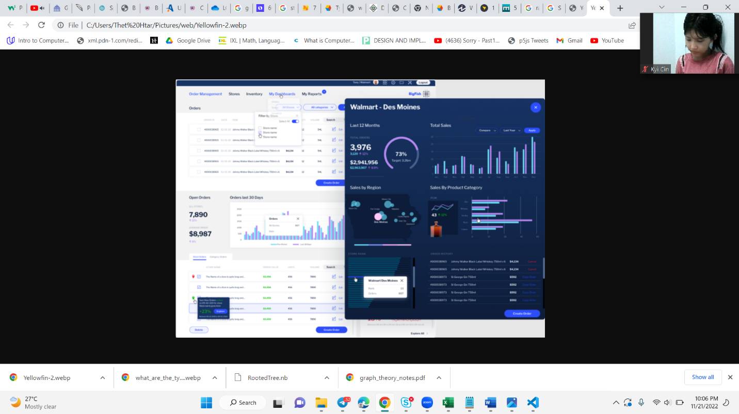

**Interactive reports**

Users are assisted in turning data into knowledge through interactive reporting. In order to promote improved decision-making, they enable users to better grasp the analysis contained in reports and the underlying data that reports are based on. The user need to be able to

* Investigate and examine reports
* Perform a slice-and-dice. OLAP evaluation
* Use analysis to illustrate data patterns, such as moving averages and regression
* To understand abnormalities in huge data sets, use time-series zooming to scan the data.
* Set data alerts that draw attention to data exceptions using conditional formatting.

Businesses may let their end-users explore data more naturally by using BI systems that give interactive reports and have a machine-readable structure. By giving businesses another source of actionable insights and data suggestions, these business intelligence tools may aid organizations in making longer-term choices.

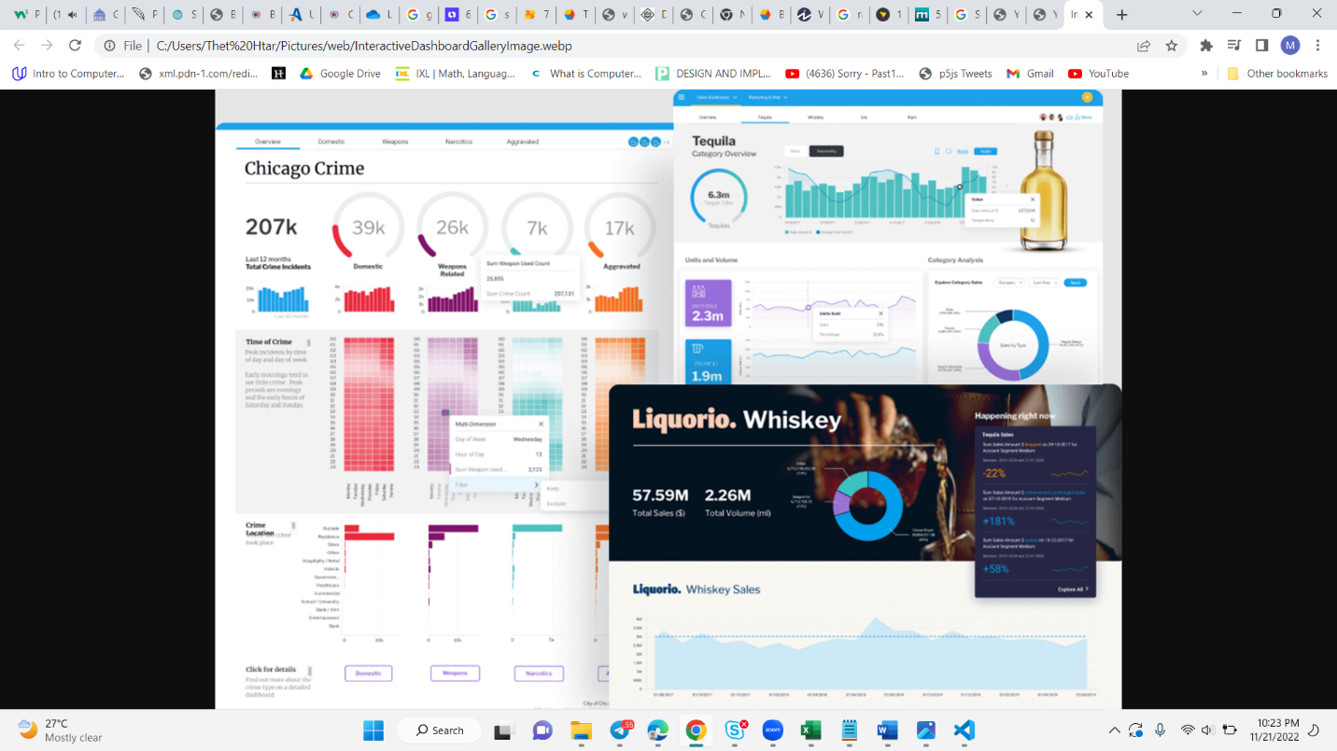

**Ranking Reports**

By choosing precise criteria, this tool enables you to generate reports that rank particular categories of data from several dimensions. You may evaluate the top and worst performing areas of your organization using ranking reports. You may, for instance, produce a report that lists the top 10 selling goods, geographic areas, or salespeople. One of the primary causes of erroneous reporting is human mistake. This is where ranking reports may help organizations automatically sort various data sets according to particular relevance and give their end customers a quick and simple way to choose which data sets require greater focus.

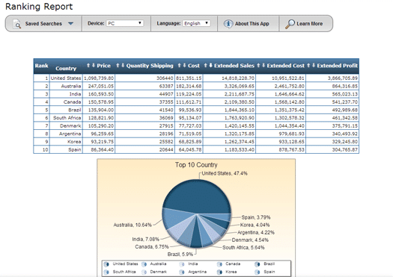

**Pivot Table**

The interactive tables known as pivot tables automatically extract, arrange, and summarize data. They are frequently used to compare data, identify patterns, and evaluate data. Pivot tables are best comprehended with a practical demonstration for individuals who are unfamiliar with them (like this one). Watch the table instantly refresh when you drag and drop a couple of the selections into the horizontal or vertical headers. One of the most common techniques for assessing data and business trends is probably using pivot tables.

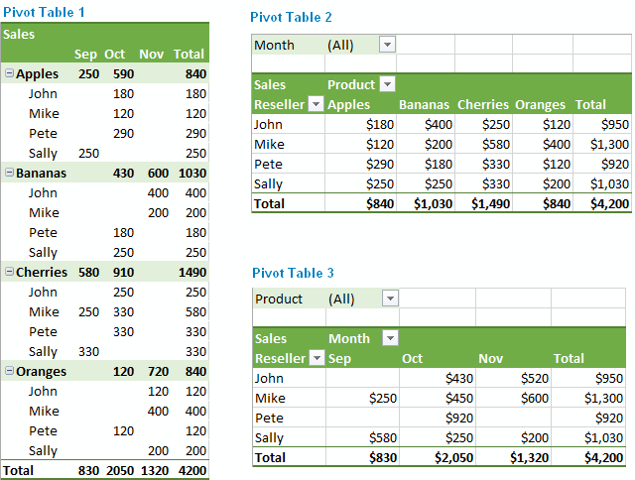

**Ad-Hoc**

Ad hoc reporting is a technique used in business intelligence to swiftly produce reports as needed. Ad hoc reports are typically prepared just once to find the solution to a particular business query, such how many support tickets were addressed last week or how many calls a salesman made yesterday. Ad hoc reports frequently show data in a visual way that makes it simple to quickly get insights. Without regard to their level of data experience, anybody with access to the necessary apps may create reports from start with the help of the appropriate ad hoc reporting tools, eliminating the need to wait for standard analysis from IT or data analyst teams.

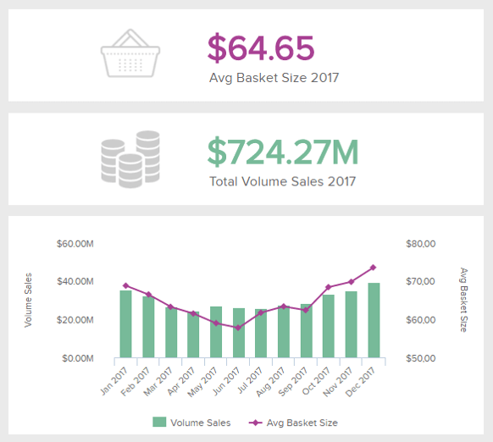

**What If analysis**

Businesses can evaluate the possible outcomes of important business decisions before they are actually taken by using "what if" analysis. Users may create strategies to accomplish corporate goals and steer clear of the standard "hit and miss" strategy using the data that is already available. This facilitates proper strategic planning by management. Future situations may be simulated using artificial intelligence (AI), and prospective repercussions of various actions can be evaluated. Businesses can use this kind of information to guide their operational and long-term planning choices. Additionally, predictive analytics may assist companies in comprehending consumer behavior and forecasting future trends.

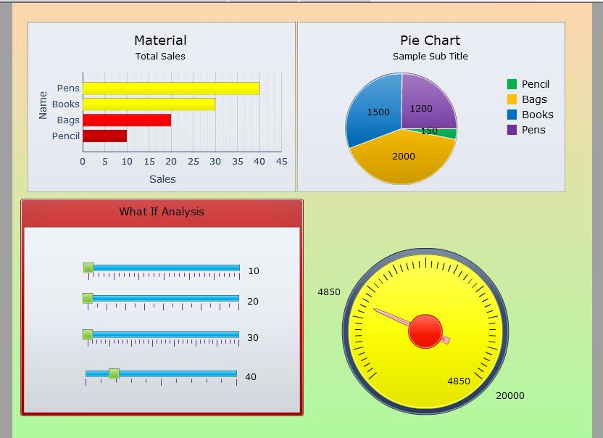

**Self-service data discovery**

The proper data must be available in order to make an educated business decision, and a BI solution should offer self-service features that let users quickly and simply access that data while also receiving a pertinent explanation and comparison to get started. To enhance data accessibility and utilization, BI systems should also enable users to exchange data with various teams inside the organization.

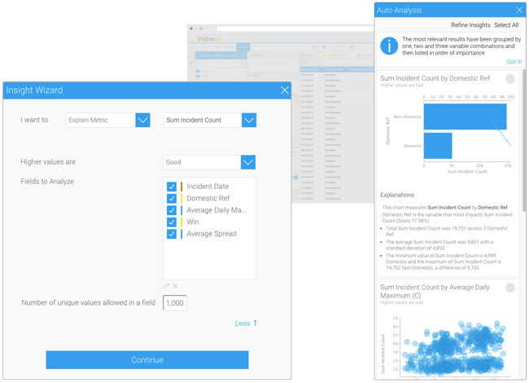

# LO 3: Demonstrate the use of business intelligence tools and technologies

## P3. Determine, with examples, what business intelligence is and the tools and techniques associated with it.

Determine what business intelligence is and tools and methods are associated with data mining, analytics, predictive modeling, OLAP, data integration, data quality and data warehousing in conjunction with other information management systems and applications with examples.

**Business Intelligence**

Business intelligence (BI) makes use of software and services to convert data into useful insights that influence the strategic and tactical business choices of a company. To give users in-depth insight about the condition of the business, BI tools access and analyze data sets and show analytical findings in reports, summaries, dashboards, graphs, charts, and maps. The phrase "business intelligence" is frequently used to describe a variety of technologies that offer quick, simple-to-understand access to insights about the present state of a company based on available data.

**Types of business intelligence tools and techniques**

In order to address various information needs, a wide range of data analysis applications are combined in business intelligence. Most are supported by both standard BI systems and self-service BI tools. The list of BI technologies that are available to organizations includes the following:

* Mobile Business Intelligence
* Tableau
* Real time BI
* Embedded Business Intelligence
* Ad hoc analysis
* Online analytical processing
* Operational Intelligence
* Software-as-a-service BI
* Open-source BI
* Powe Bi Desktop
* Location Intelligence

I will use the power bi desktop for my business processes. Because I can do different type of reports to show the detailed information so I can make the right decision by viewing these reports.

**Business Intelligence Techniques**

Companies can utilize a variety of business intelligence techniques to gather insightful data for decision-making. Here are some of the most popular BI methods.

* Analytics
* predictive Modeling
* Online analytical processing
* Data Mining
* Model Visualization

### ETL

The data integration process known as ETL, or extract, transform, and load, brings together data from several data sources into a single, consistent data store that is then put into a data warehouse or other destination system. Workstreams in data analytics and machine learning are built on the basis provided by ETL. ETL cleans and arranges data through a set of business rules in a way that satisfies particular business intelligence requirements, such monthly reporting, but it can also handle more complex analytics that might enhance back-end operations or end-user experiences. ETL is frequently used by an organization to:

* Data extraction from old systems.
* Cleanse the data to raise its consistency and quality.
* Load data into the desired database.

**Extract**

Raw data is transferred or exported from source locations to a staging area during data extraction. Data may be extracted from a range of structured and unstructured data sources by data management teams. These include, but are not limited to:

* SQL or NoSQL servers
* CRM and ERP systems
* Flat files
* Email
* Web pages

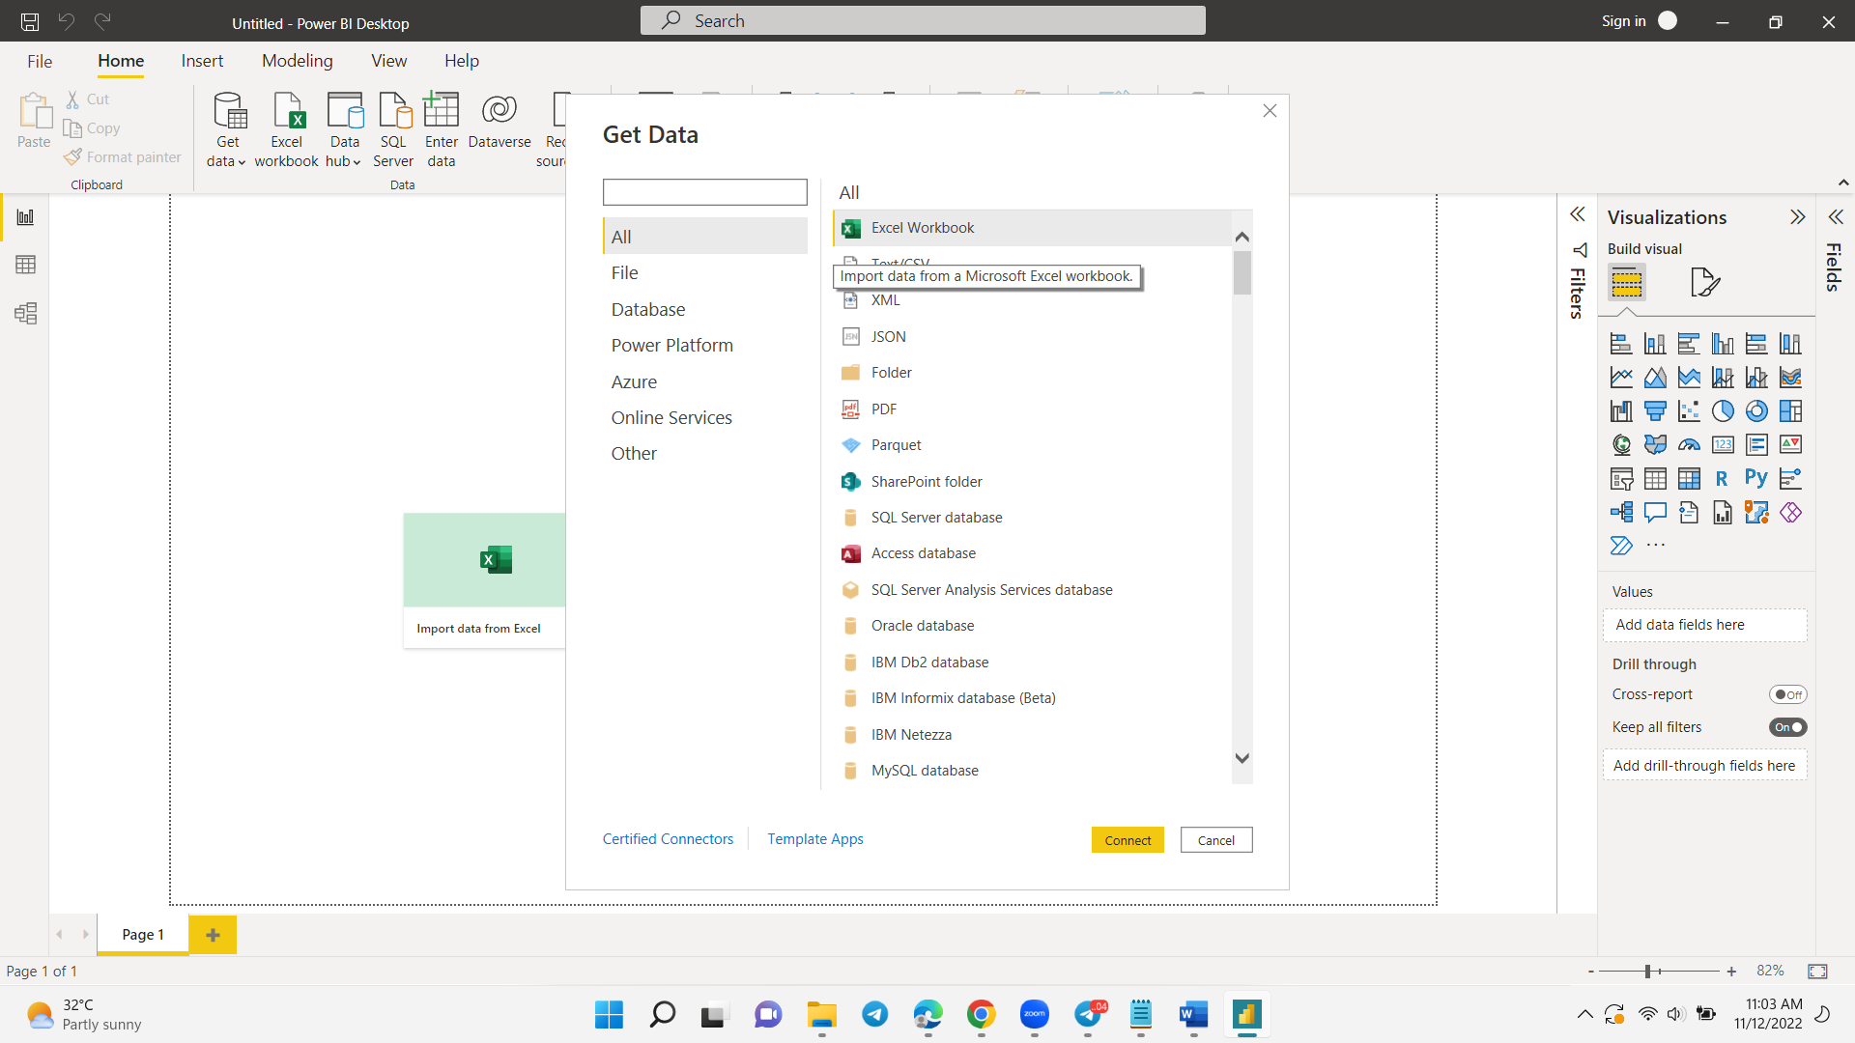

Fig ()Step 1

From the Power BI splash screen or toolbar, click on “Get Data,” select the Excel connector and click “Connect.”

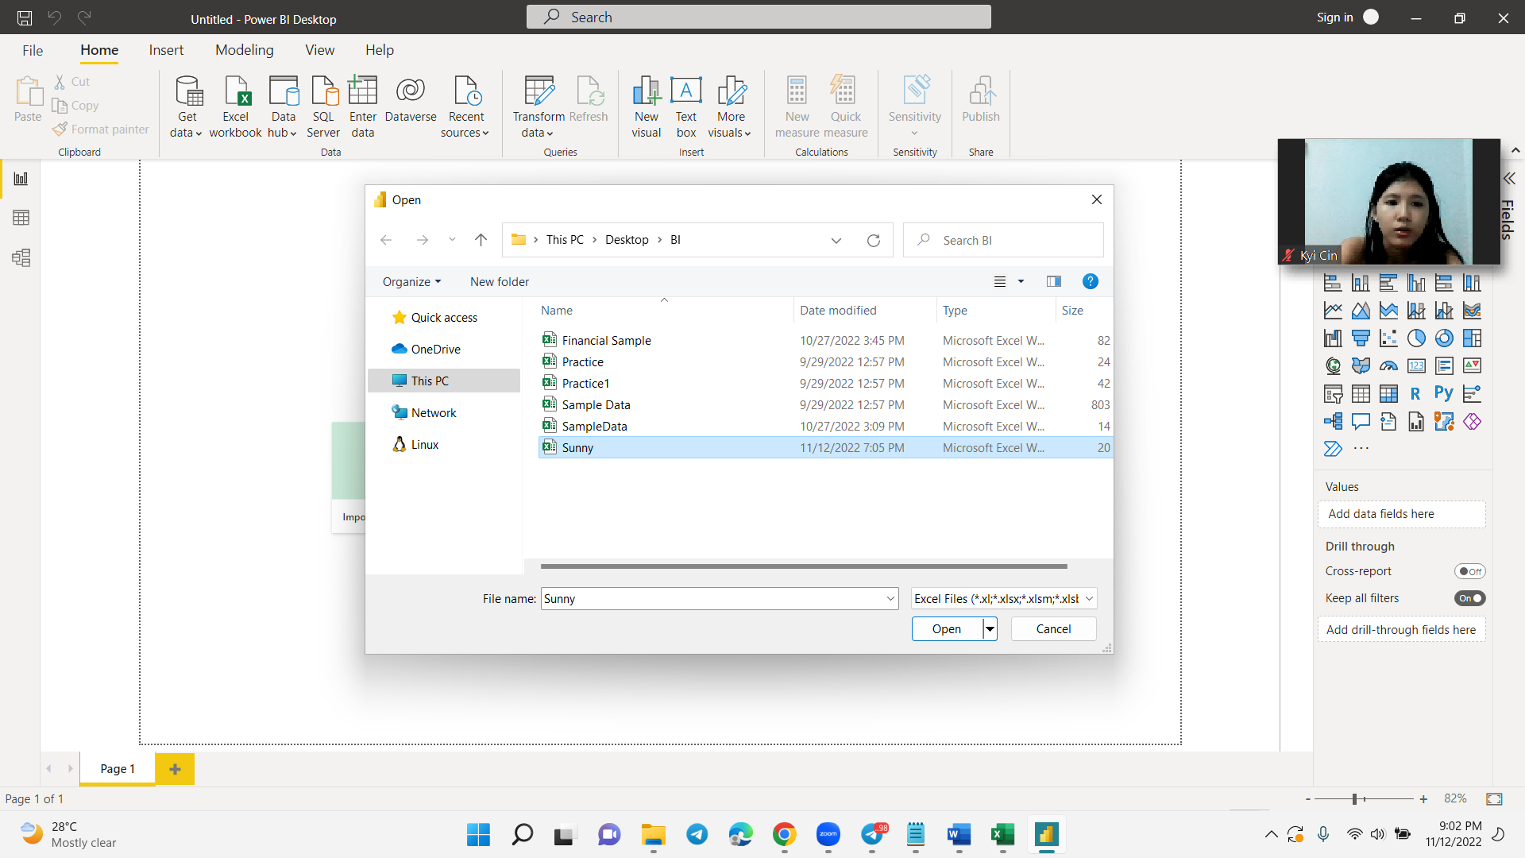

Fig () Step 2

Browse for the Excel file, select it from the list and click “Open.”

**Transform**

The staging area is where the raw data is processed. For its intended analytical use case, the data is changed and consolidated in this place. The following tasks may be involved in this phase:

* The data is filtered, cleaned, duplicated, validated, and authenticated.
* Use the raw data to do computations, translations, or summaries. This may entail modifying text strings, updating row and column headings to ensure uniformity, converting money or other units of measurement, and more.
* Conducting audits to verify data compliance and quality
* Deleting, encrypting, or safeguarding information under the control of authorities such as the government or industry
* Data formatting to create tables or combine tables in accordance with the destination data warehouse's structure.

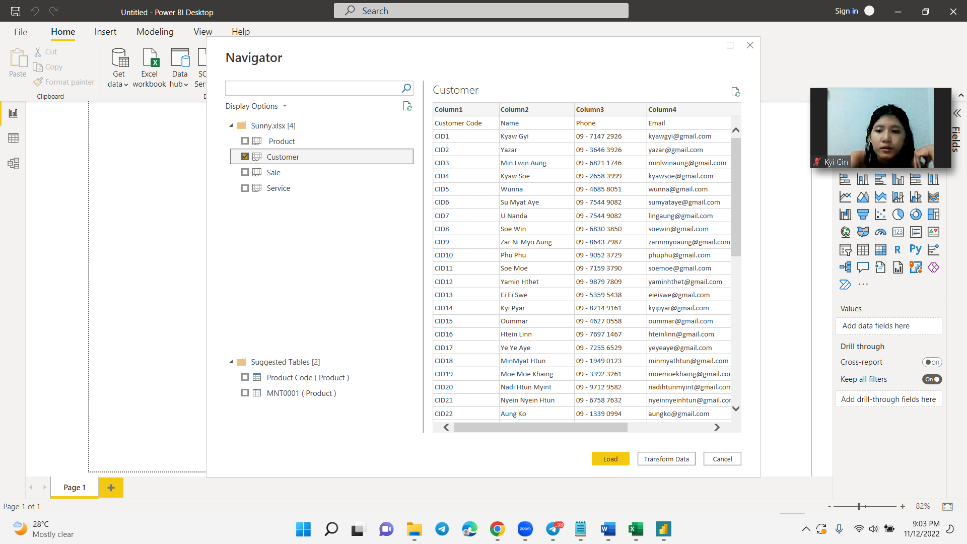

Fig () Step 3

On the Navigator dialog, select “Department” and click “Transform ”.

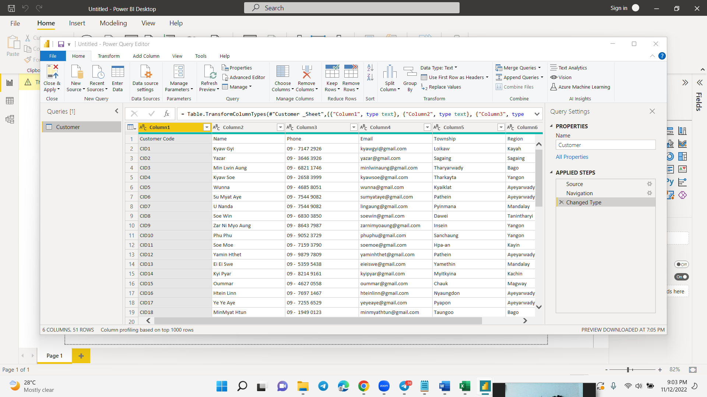

Fig () Step 4

The Power Query Editor opens to shape and transform our data.

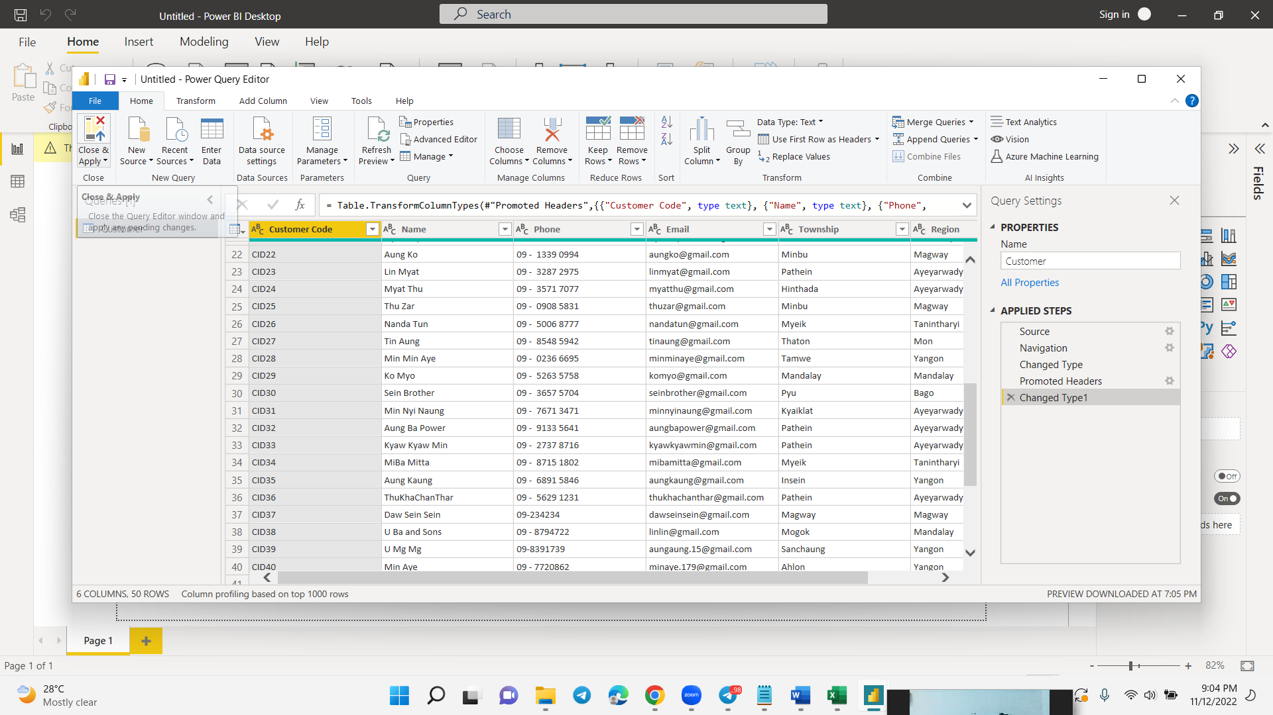

Fig () Step 5

Now, we can indicate that the first row should be used as our column headers. To do this, click the “Use First Row as Headers” option on Power Query toolbar. Our table now shows the correct column headers.

**Load**

The converted data is sent from the staging area into the target data warehouse in this final stage. This often entails initial loading of all data, recurring loading of incremental changes to the data, and, less frequently, full refreshes to completely remove and replace all data in the warehouse. Most businesses that employ ETL have automated, well-defined, batch-driven processes that are continuous. ETL often takes place after business hours when usage of the data warehouse and source systems is at a minimum.

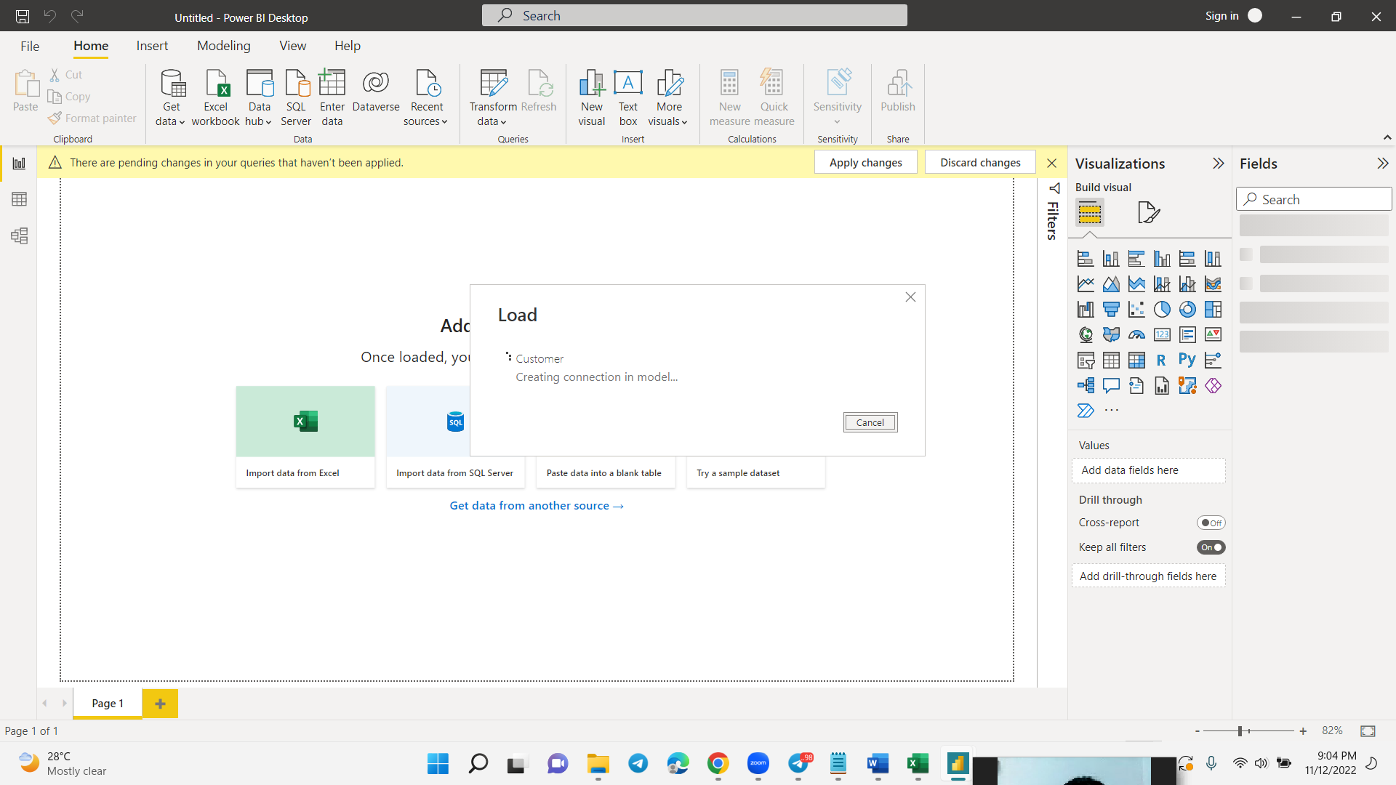

Fig () Step 6

Click the Apply and Close to do load process. And that will arrive to the power bi page.

### Data Wearhouse

A particular form of data management system called a "data warehouse" is intended to facilitate and assist business intelligence (BI) operations, particularly analytics. Data warehouses frequently have a lot of historical data and are used to run queries and analyses. A data warehouse often uses a variety of sources, including transaction programs and application log files.

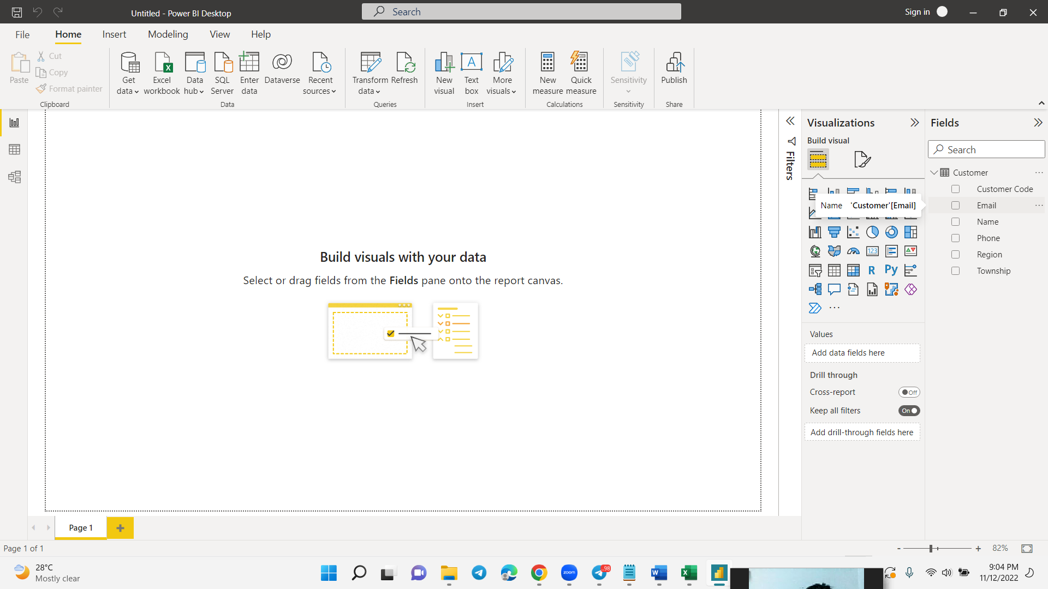

Fig () Step 7

And then that data will arrive to the data Wearhouse in the power bi desktop.

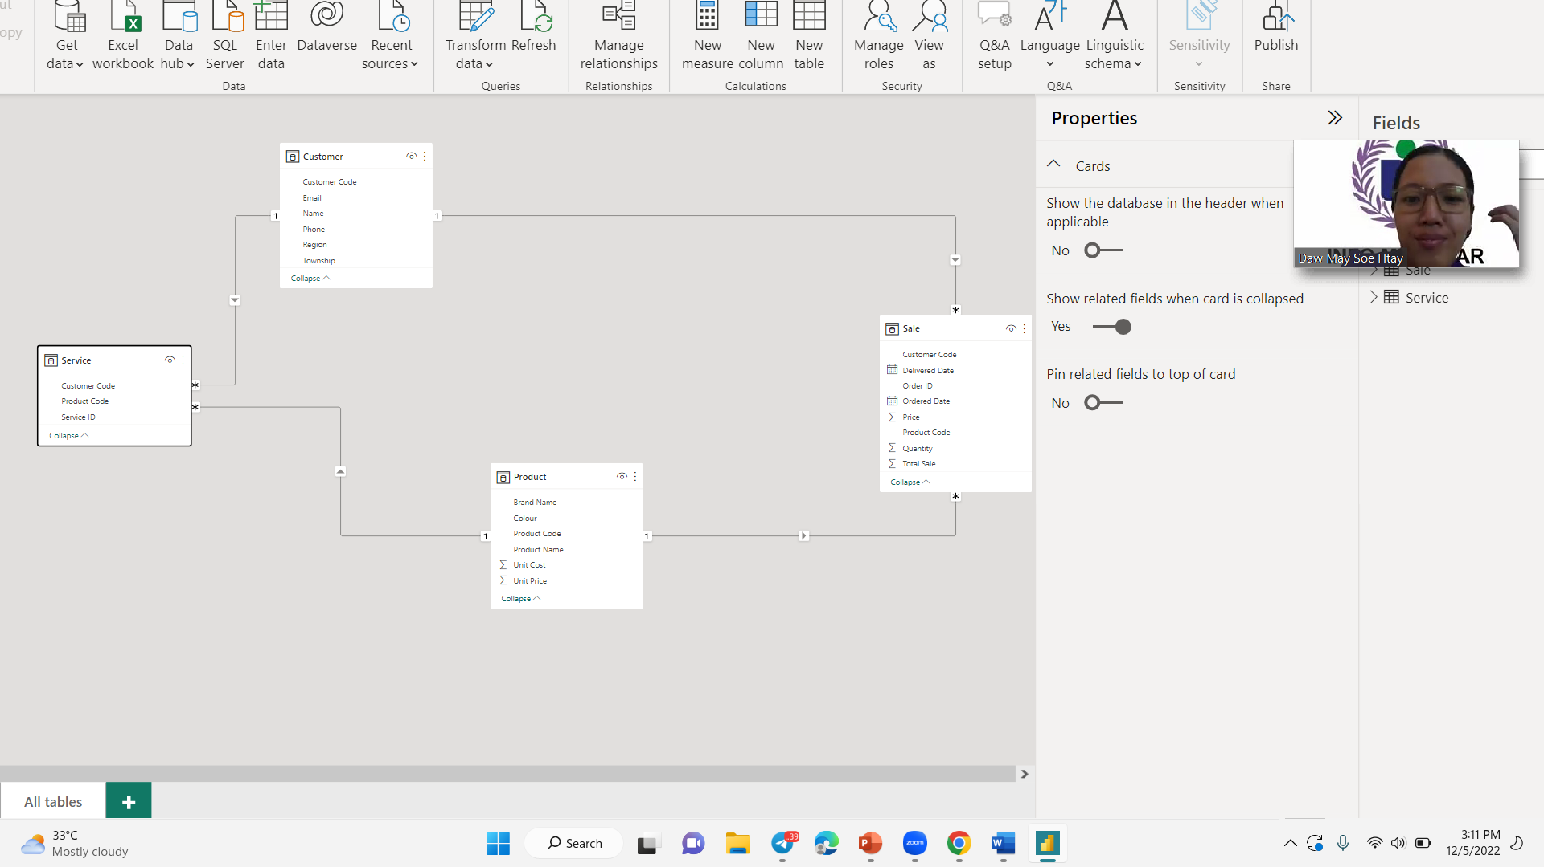

Fig () The model view of the data wearhouse

### Data Mining

Finding information, patterns, and insights in data is the art and science of data mining. It is the process of removing practical patterns from a structured data set. Valid, novel, potentially useful, and comprehensible patterns are required. The underlying idea is that historical data can reveal patterns of behavior that can be extrapolated into the future. The multidisciplinary field of data mining incorporates methods from numerous other disciplines. It makes use of the databases field's understanding of data organization and quality. It incorporates modeling and analytical methods from the fields of computer science and statistics (artificial intelligence). Additionally, it utilizes decision-making expertise from the discipline of business management. In the context of pattern recognition in defense, such as determining a friend or foe on a battlefield, the field of data mining first emerged. It has evolved to give businesses a competitive edge, like many other defense-inspired technologies.

**Classification**

A fundamental data mining approach that may be used in almost any sector is classification. It is a procedure wherein data points from huge data sets are categorized according to how they are being used. Classification is considered to be a form of clustering in data mining since it is beneficial for collecting comparable data points for comparative analysis. In order for enterprises to acquire deeper insights, classification is also used to identify sizable groupings within a demographic, target audience, or user base.

**The example of classification**

To sell new loans or forecast credit card risks, financial firms categorize individuals based on a variety of factors. In the meanwhile, weather applications categorize data to forecast snowfall totals and other comparable metrics. In order to anticipate purchasing patterns, grocery shops also employ categorization to categorize items according to the customers that purchase them.

**Regression**

A popular statistical method for modeling the connection between a number of independent variables (DVs) and a single dependent variable is regression. In a multidimensional space, where each independent variable represents a dimension, the goal is to locate the curve that best fits the dependent variable. The curve could be nonlinear or it might be a straight line. A coefficient of correlation , which is the square root of the amount of variation explained by the curve, may be used to assess how well the curve fits the data.

Regression's primary steps are straightforward:

1. Make a list of every variable that can be used to build the model.

2. Choose an interesting dependent variable.

3. Look into any visual connections between the variables of interest.

4. Discover a method to predict the dependent variable using the independent variables.

**The example of Regression**

**Association**

To identify correlations or connections between points in a data gathering, association rules are utilized. To find unusual or interesting relationships between variables in databases, data miners utilize association. Association is frequently used by businesses to assist them to decide on their marketing strategy and research. In data mining, association rules are useful for analyzing and predicting customer behavior. They play an important part in customer analytics, market basket analysis, product clustering, catalogue design and store layout.

Programmers use association rules to build programs capable of machine learning. Machine learning is a type of artificial intelligence (AI) that seeks to build programs with the ability to become more efficient without being explicitly programmed.

**The example of association**

An association between diapers and beers is a well-known example of an association rule. The scenario, which appears to be made up, suggests that males are more inclined to purchase beer when they visit a store to buy diapers. Data that would support that may appear something like this: 200,000 customers trade at a supermarket. The purchase of diapers is included in around 4,000 transactions, or about 2% of all transactions. Beer is bought in about 5,500 transactions (2.75%) total. Of them, almost 3,500 transactions, or 1.75 percent, involve the acquisition of both beer and diapers. According to the percentages, the high figure ought to be far lower. However, the fact that around 87.5% of diaper purchases also include buying beer suggests a connection between diapers and alcohol.

**Clustering**

Clustering is a method for representing data graphically, such as in graphs that display purchasing patterns or customer demographics for a specific product. A collection of various data objects is categorized as similar objects by clustering. A single cluster is a collection of data. If we were to define clustering in data mining, we might say that it is basically the process of grouping a set of abstract objects into groups of similar objects. Data sets are divided into different groups in the cluster analysis, which is based on the similarity of the data. Cluster analysis is the method used to divide them into these groups and store them in.

**The Example of Clustering**

Clustering makes it easier for businesses to handle their data. Retailers can use clustering models, for instance, to identify which customers buy specific products, on which days, and how frequently. This can assist shops in marketing goods and services to customers in a specific region or demographic.

Grocery stores can use clustering to organize products according to a variety of characteristics (brand, size, cost, flavor, etc.) and better understand their sales tendencies. It may also be useful to auto insurance providers looking to better accurately price their policies by identifying a group of clients who frequently file large annual claims. Additionally, banks and other financial institutions may use clustering to effectively arrange branch hours and staffing by better understanding how clients use in-person vs virtual services.

### OLAP

OLAP facilitates the analysis of various extracts and the several perspectives that may be taken on business data. Data must frequently be joined and aggregated. The OLAP cube is the general name for the structure. A data format that is well-suited for accurate data analysis is the OLAP cube. It primarily consists of numerical facts, which are referred to as dimensions. At the same time, OLAP cubes are referred to as "Hyper cubes," allowing users to perform Multidimensional Analytical querying for the necessary data using standard OLAP operations like Drill-down, Roll-up, Slicing, Dicing, and Pivot. Data should be retrieved from a variety of sources and formats by a data warehouse.

**Roll-up**

By descending idea hierarchies, or dimension reduction, the roll-up operation—also known as drill-up or aggregation operation—performs aggregation on a data cube. Rolling up is like zooming-out the data cubes.

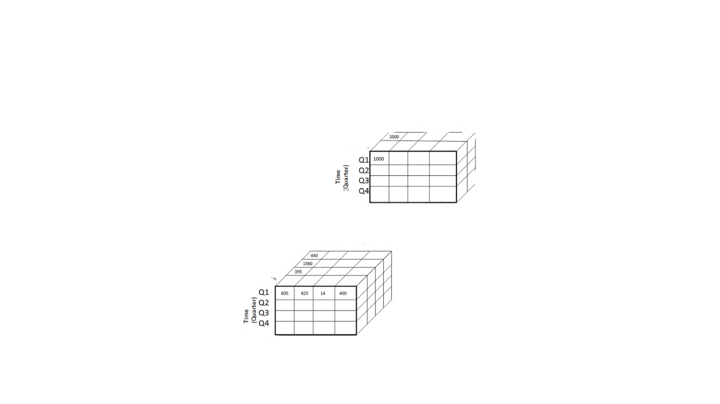

CID Cname Phone Email

Tharkayta

Pyinmana

Insein

Meiktila

CID Cname Phone Email

Yangon

Mandalay

Roll-up on location( from township to region)

Fig (3.) Roll up operations

Roll-up is performed by climbing up a concept hierarchy for the dimension location.

Initially the concept hierarchy was "Township < Region".

On rolling up, the data is aggregated by ascending the location hierarchy from the level of township to the level of Region .

The data is grouped into township rather than Region .

When roll-up is performed, one or more dimensions from the data cube are removed.

**Drill-down**

The roll-down operation, also known as the drill-down operation, is the opposite of the roll-up procedure. Similar to zooming in on a data cube, drilling down. It moves from a record with less detail to one with more detail. Drill-down can be done by either adding more dimensions or moving down a concept hierarchy for a dimension.



CID Cname Phone Email

CID Cname Phone Email

Tharkayta

Pyinmana

Insein

Meiktila

Tharkayta

Pyinmana

Insein

Meiktila

Drill down on time (from quarter to month)

Fig(3.) Drill-Down Operation

Drill-down is performed by stepping down a concept hierarchy for the dimension time.

Initially the concept hierarchy was "day < month < quarter < year."

On drilling down, the time dimension is descended from the level of quarter to the level of month.

When drill-down is performed, one or more dimensions from the data cube are added.

It navigates the data from less detailed data to highly detailed data.

**Slice**

An individual value for one or more members of the dimension is represented by a slice, which is a subset of the cubes. When a consumer requests a selection on one side of a three-dimensional cube, for instance, a slice operation is carried out, creating a two-dimensional site. In order to create a sub cube, the Slice procedures make a pick on one dimension of the provided cube.



CID Cname Phone Email

CID Cname Phone Email

Tharkayta

Pyinmana

Insein

Meiktila

Slice for time “Q1”

Fig( 3.) Slice Operation

Here Slice is performed for the dimension “time” using the criterion time = “Q1”.

It will form a new sub-cube by selecting one or more dimensions.

**Dice**

This procedure is comparable to a slice. The distinction between dice is that you may choose two or more dimensions to produce a sub-cube.

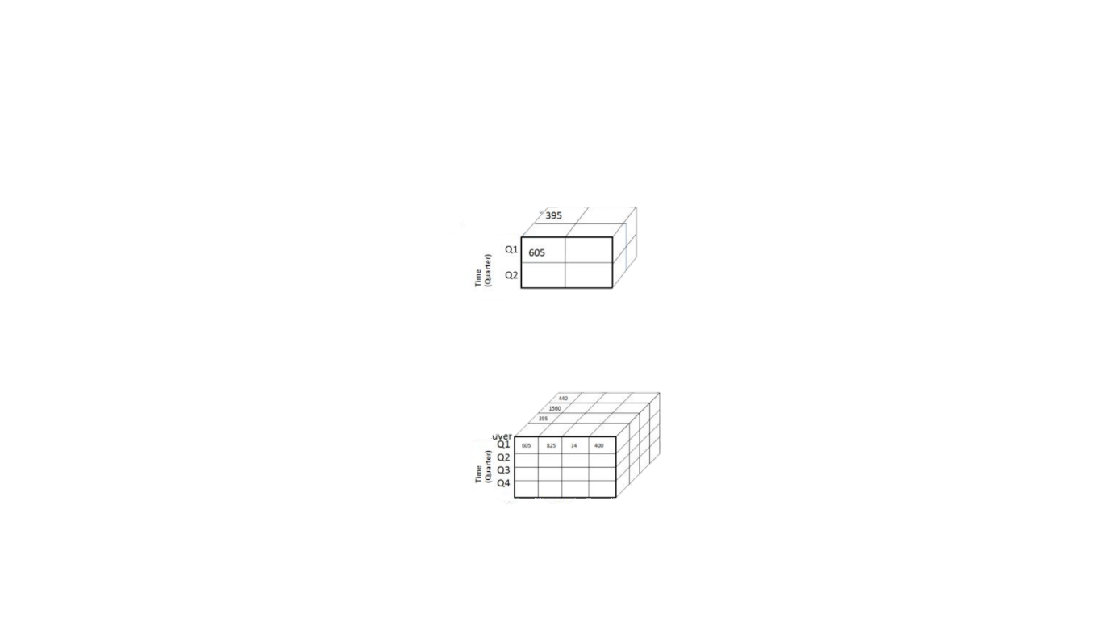

CID Cname Phone Email

Tharkayta

Pyinmana

Insein

Meiktila

Tharkayta

Pyinmana

Insein

Meiktila

Dice for( Location= “Tharkayta” or “Pyinmana”) and (time=”Q1” or “Q2”) and ( item=”CID” or “Cname”)

CID Cname Phone Email

Fig(3.) Dice operation

The dice operation on the cube based on the following selection criteria involves three dimensions.

(location = "Tharkayta” or “Pyinmana")

(time = "Q1" or "Q2")

(item =" CID" and “Cname”)

**Pivot**

Rotation is another name for the pivot action. A pivot is a visualization procedure that turns the data axes visible to offer a different way to show the data. The rows and columns could be switched about, or one of the row-dimensions might be shifted into the column dimensions.



CID Cname Phone Email

Tharkayta

Pyinmana

Insein

Meiktila

Tharkayta

Pyinmana

Insein

Meiktila

CID Cname Phone Email

Fig (3.) Pivot operation

## P4.Design a business intelligence tool, application or interface that can perform a specific task to support problem-solving or decision-making at an advanced level.

Produce the reports that design the visualizations of a business intelligence tool, an application or an interface that can perform a specific business process to support problem-solving or decision-making at an advanced level such as operational, tactical and strategic.

Make a presentation about the benefits and drawbacks of business intelligence solution for your business process.

**Strategic Level Report**

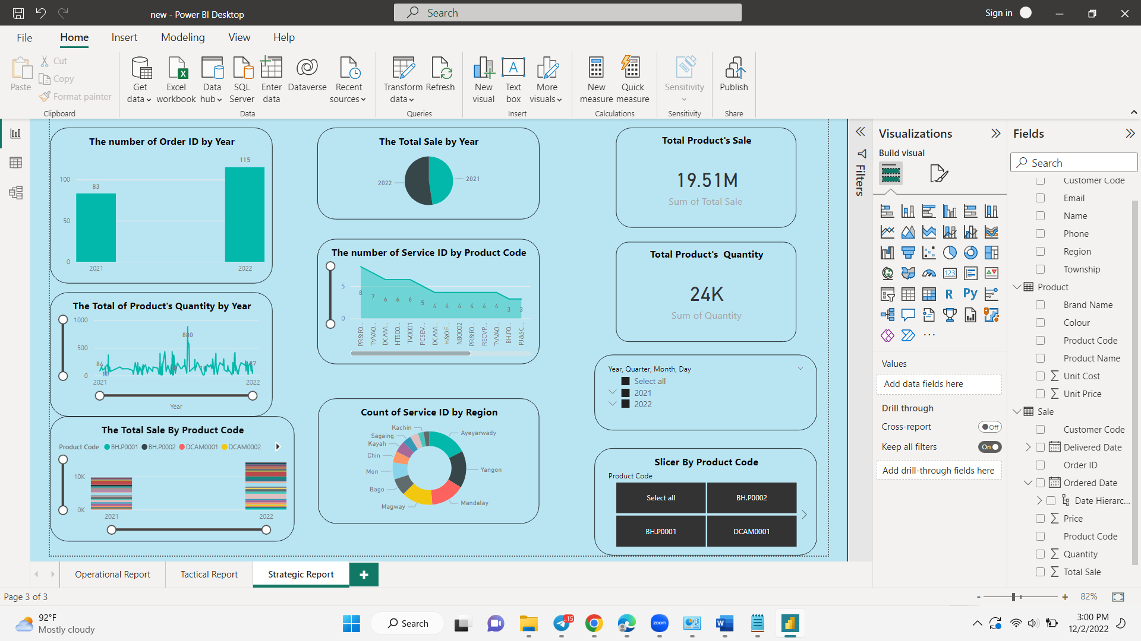

Fig (3.) Strategic Level Report

In this strategic level, the people can see the long-term goal from this report. The people of this level can do all main decision for the whole organization. In this report , the brief view of all of information by years. The first one is the number of order by years. So you can see the improvement on this dashboard. In 2022, the order improve so much . Therefore, they need to maintain their flows and that would be great decision for organization. The next report is the total ordered product’s quantity for each years and total sales for each year. And then they also know about the total sale for each product. So, they know which Proceware projector product is the most popular on customers by viewing this reports. Thus, they can make a decision that is Proceware projector product should do more stocks and which SV&DVDE 100 product does not do stock as much. And then they need to think about the product trend on these days. Therefore, they also have to make also a decision that is which products might be popular on these days and should do launched new other products. The next one is that show how many time arrive the product on service departments. Thus, they can know the most error products and then they have to give the warning information to the related products of other organizations. In this report, they can do slicer with years and each products. So that they can view report information by each year or by each product.

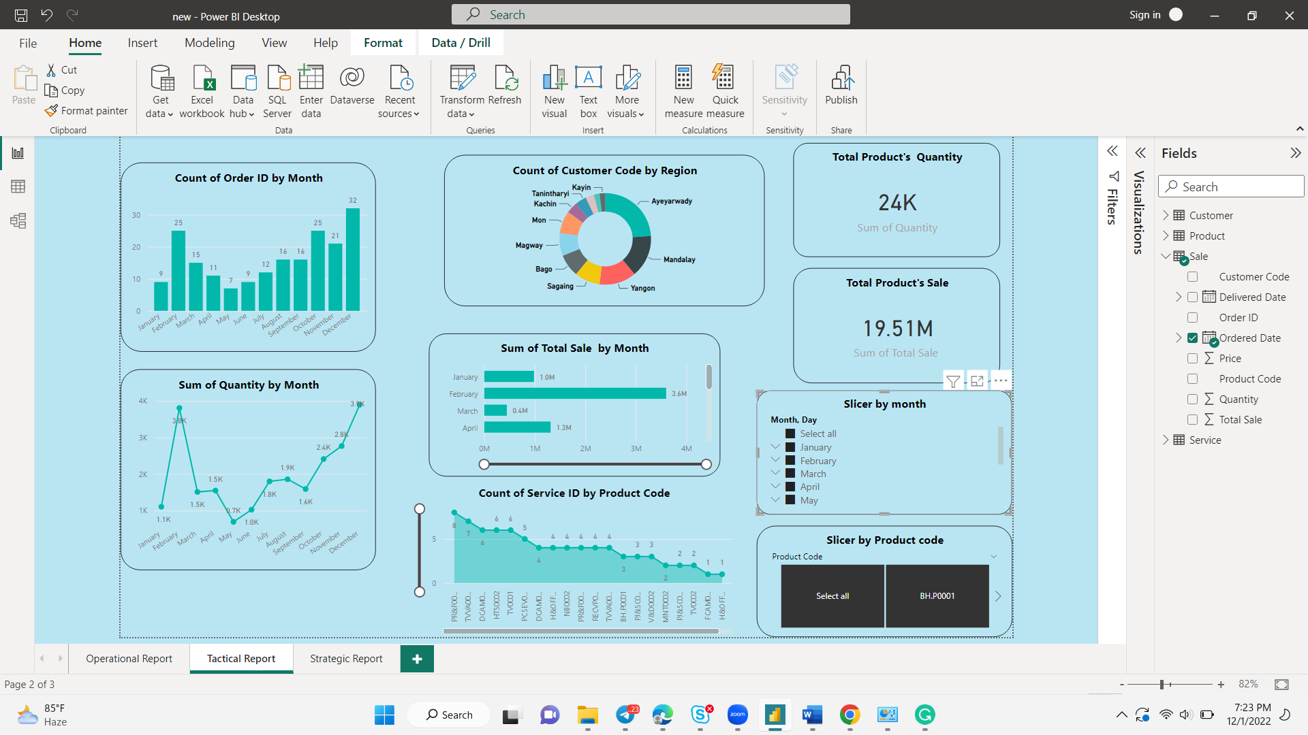

Fig (3.) Tactical Level Report

In this tactical level, the people can see all of the review by month as a short-term. In this dashboard, they can see how many orders by each month. Thus, they can do the detailed and brief about of the number of order for each month. They can know which December and May months have the most and least orders, and May months with low orders, you can make decisions about how to make plans and increase sales. And then they also know the total quantity ordered product by each month. So that they can know which December can get the most quantity of ordered product .After that, they can know the number of customer for each region. So they know which parts and region are the needed more attention and need to test which products might be useful for them from our organization. Thus, they need to produce the survey questions for each regions and then give it to the operational level. Afterthat they have to collect the correct data. The next report is the total sale price of all products for each month. Then they also know about the count of service product by product code. This level report have two slicers , that is slicer by year and slicer by Product code.

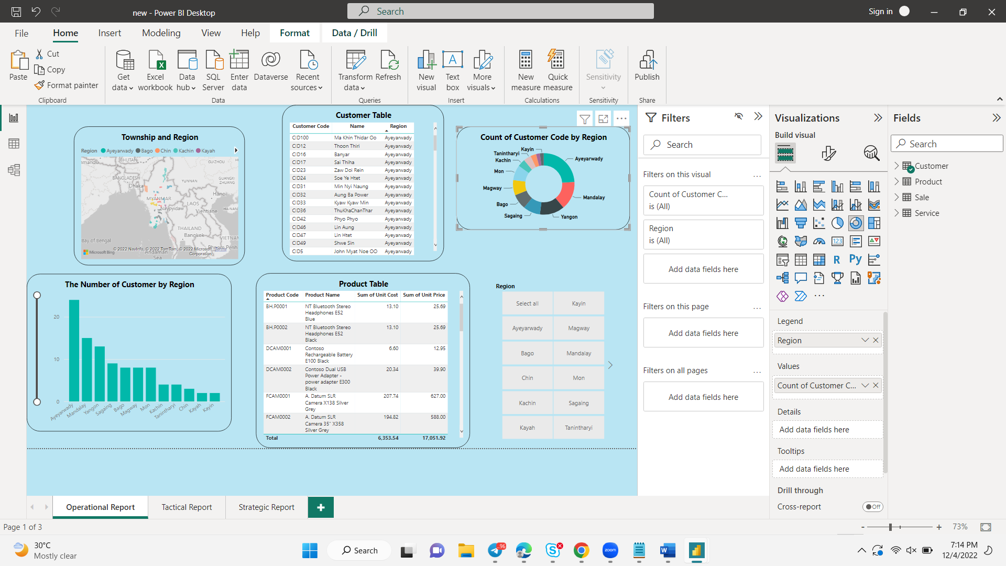

Fig (3.) Operational Level Report

In this operational level, the people can see the detailed about of the product’s information and customer’s information . The next report is the map of the Customer. And then they can see the total of Product’s Quantity by product code of the order. And then they can see the number of customer by regions for the organization. Therefore, they can know how many customers where are by region. Therefore, they can know which Ayeyarwady and Kayin region has the most or least customers. In the Kayin regions with the fewest customers, you can make decisions about what kind of plans and attractions to get the attention of customers .So that they have to do survey questions from the tactical level for those region. So they can do where is the weakest places in their organization. Afterward, they can view the total product’s quantity by customer’s orders. they can do the decision depend on the customer’s product sales, they can give the gift vouchers and lucky draw tickets by the limit control of tactical level. And then this chart and reports can see easily what is the highest values and lowest values. They can use the slicer tool to view information reports for each region.

## M3. Customize the design to ensure that it is user-friendly and has a functional interface.

### Pie Chart of the Total Sale By Year for Strategic Level

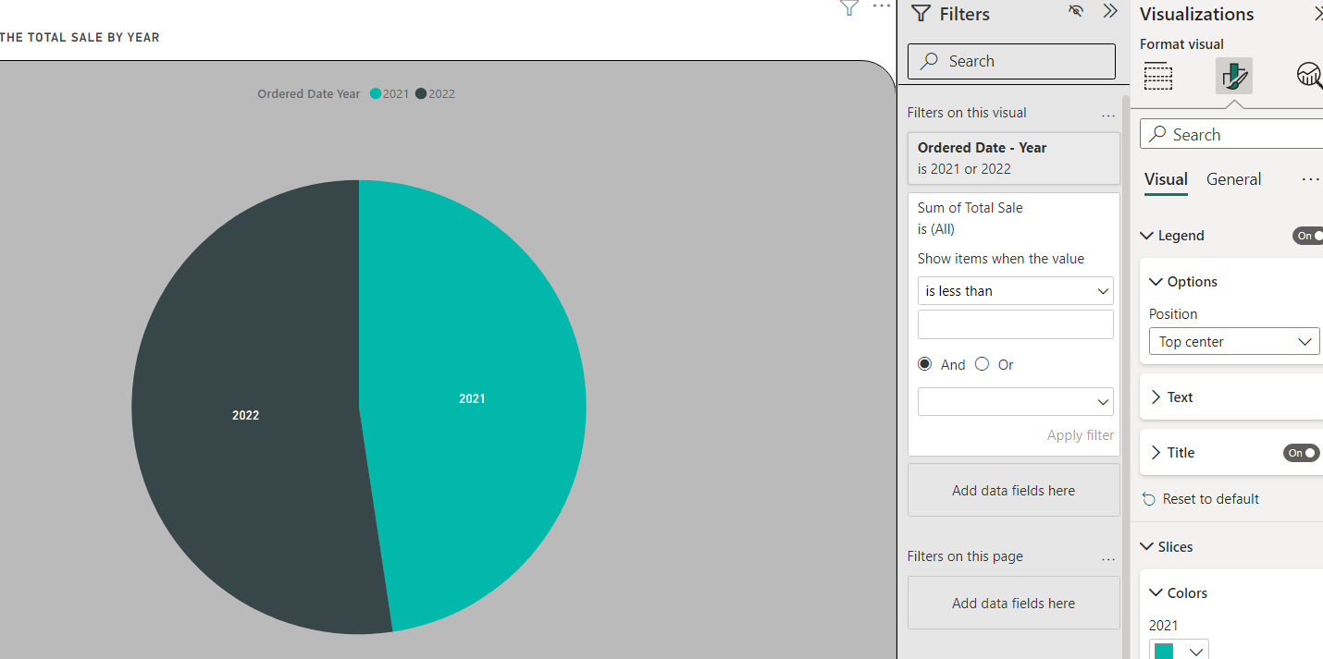

Fig (3.)

In this pie chart, I did the product total sale for each yar. In this figure can see the filters. In this area can do limitation for the total sale and order date that they want to be as a user-friendly.

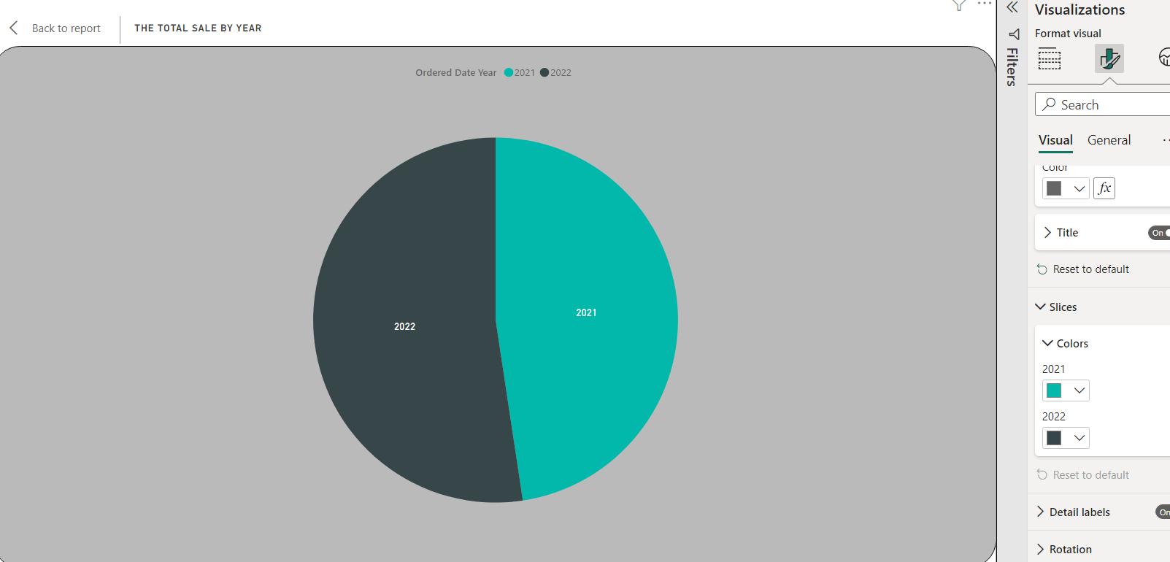

Fig (3.)

This picture shows that it easily distinguishes the value by clicking the slice from the visual of the visualization that can change the color of the pie.

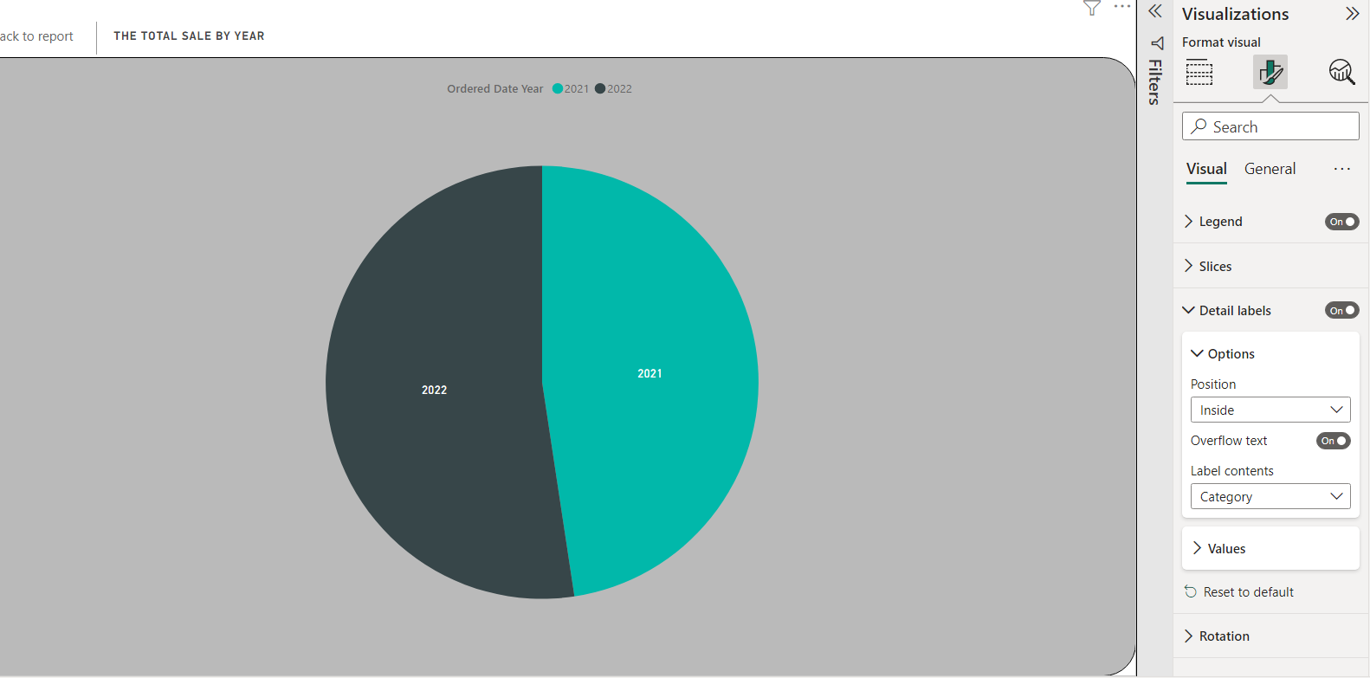

Fig (3.)

This one is the to show the positions and content of the value . t is more obvious and makes this report user friendly for users.

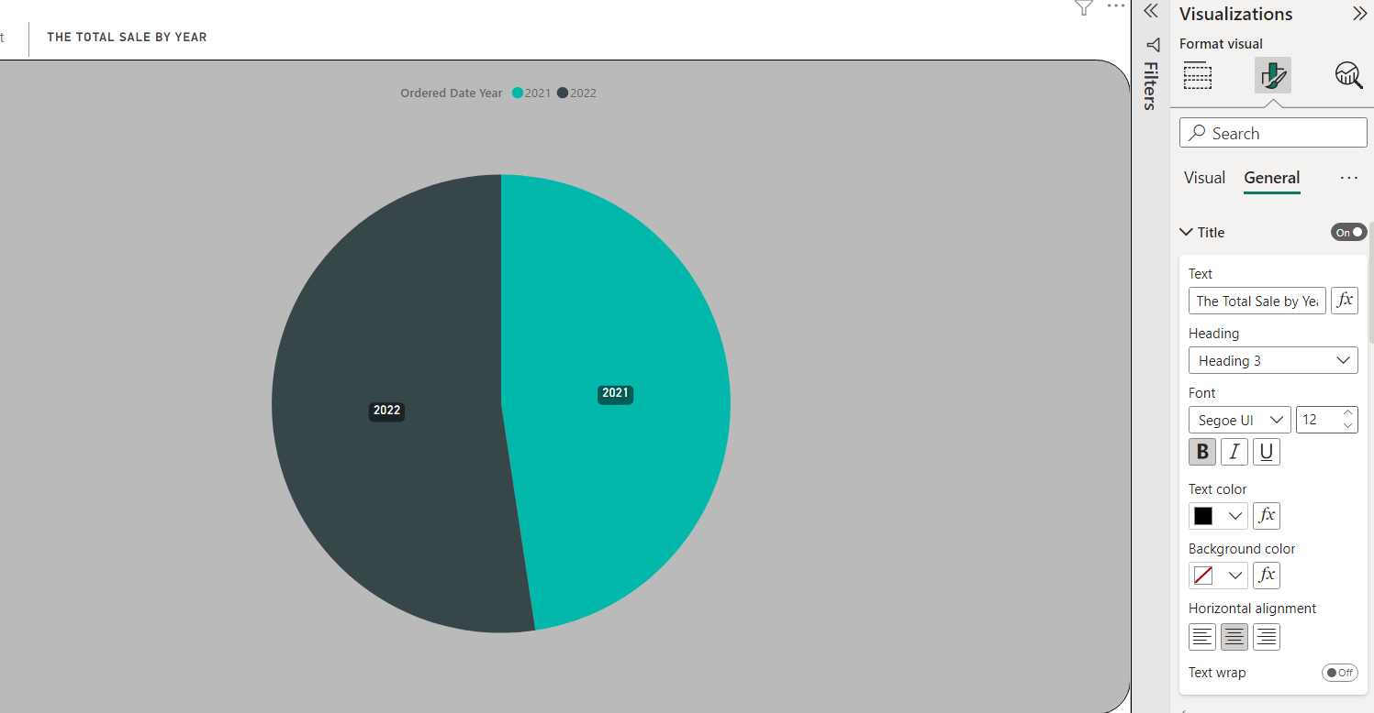

Fig (3.)

This is one of the cases of pie report customization, it is the customized steps to change the titles to the desired form so that it can know clearly what this pie report is.

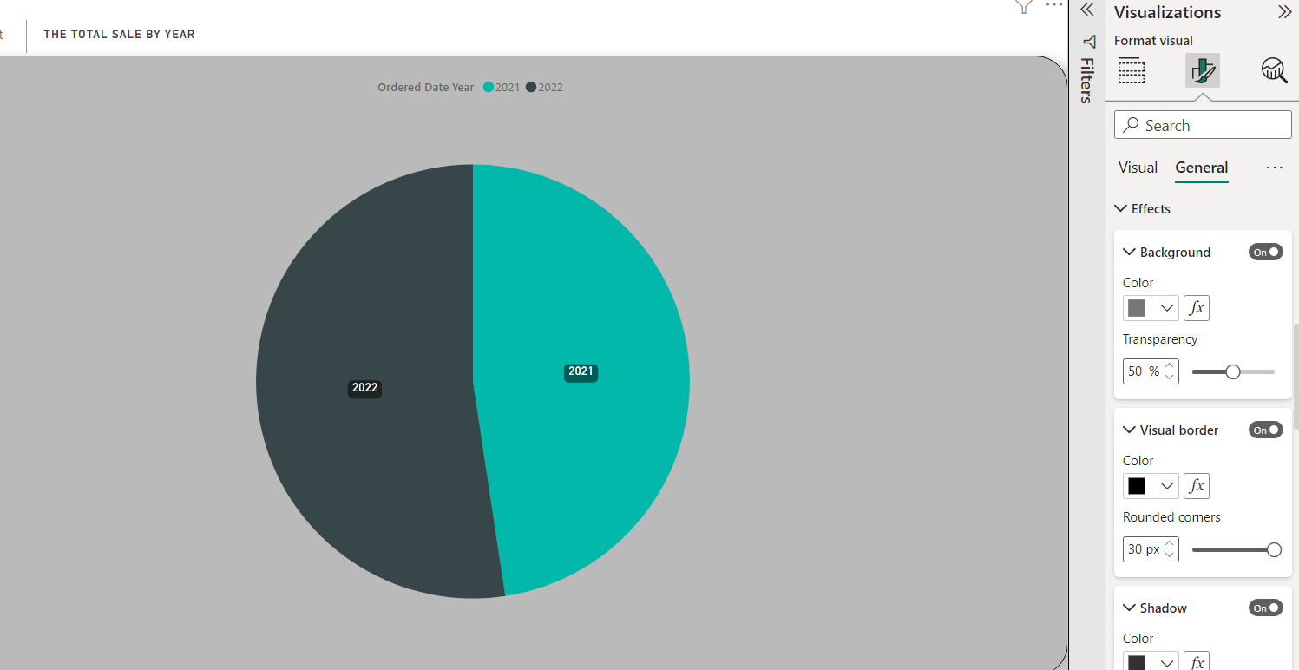

Fig (3.)

In this case, you can customize the background, visual borders, and shadows to make this pie report noticeable, and this report has been made user friendly for viewers.

### Area Chart of the Number of service ID by product code for Strategic Level

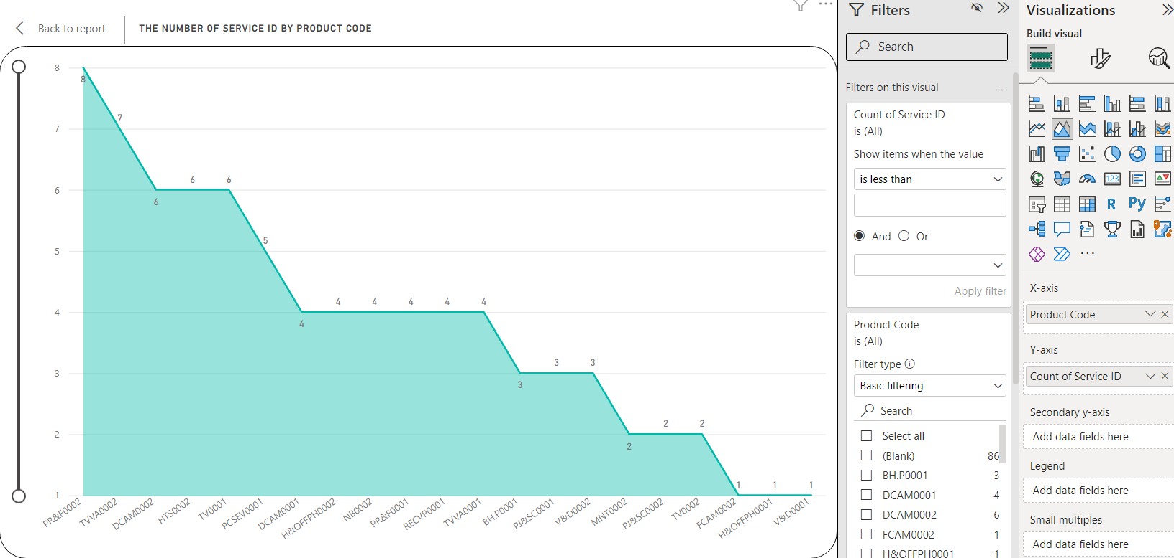

Fig (3.)

In this area chart, you can precisely do the items you want to limit in place of filters. In this report, you can limit the number of product IDs and count of customer IDs, so you can get the information you want accurately.

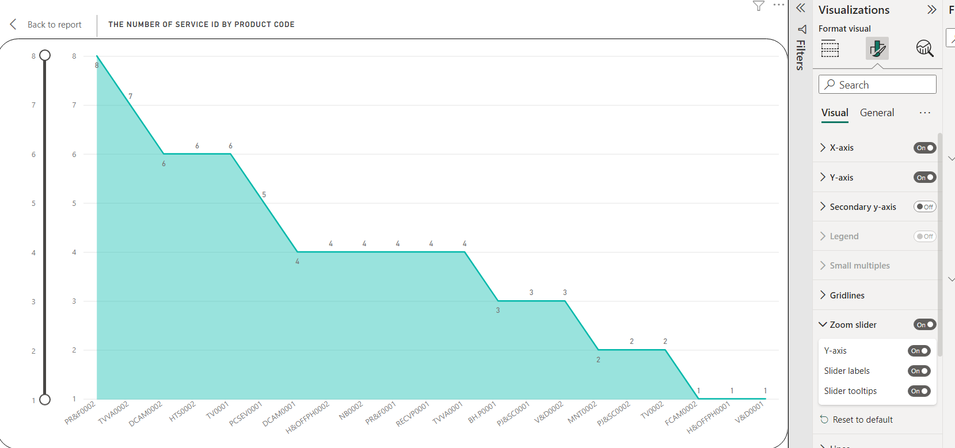

Fig (3.)

And in the visualization, by turning on the values ​​of X axis / Y axis, the values ​​can be clearly seen, making it user-friendly. And by adding a zoom slicer, it is a customizing that makes it convenient for users to view the report.

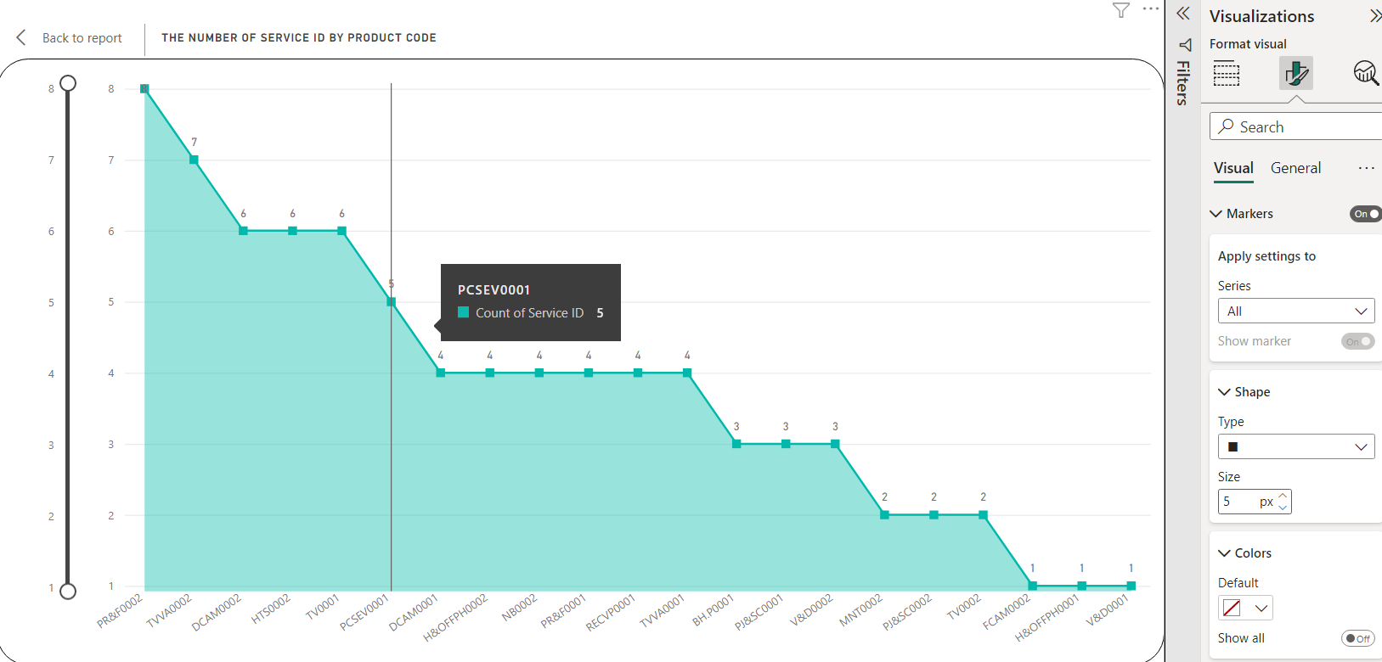

Fig (3.)

Here, you can customize the shape types to your liking so that you know the place of each value. Then you can customize the color to make the shape types more obvious.

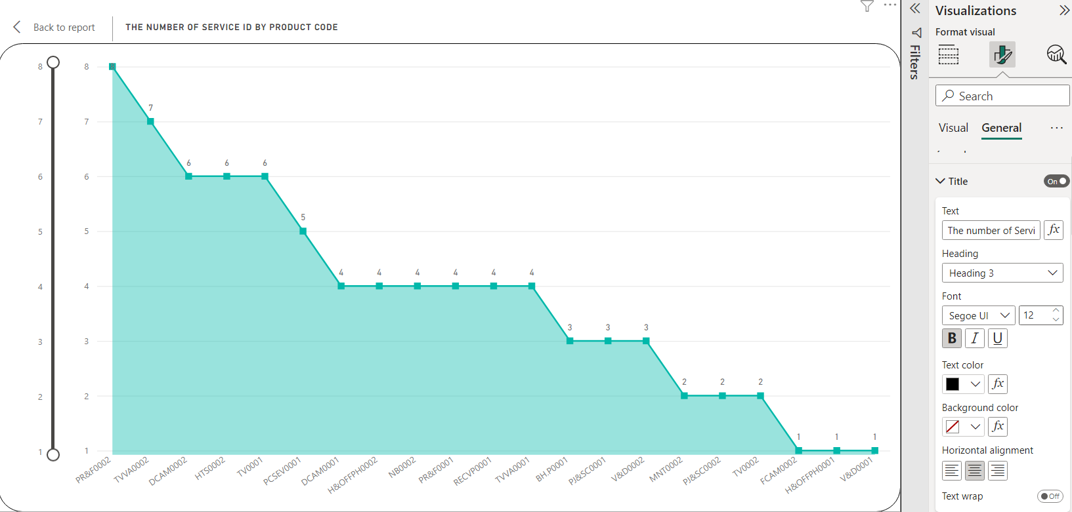

Fig (3.)

This is a case of a customized area chart report; the names have been changed to the required form so that it is clear what this pie report is.

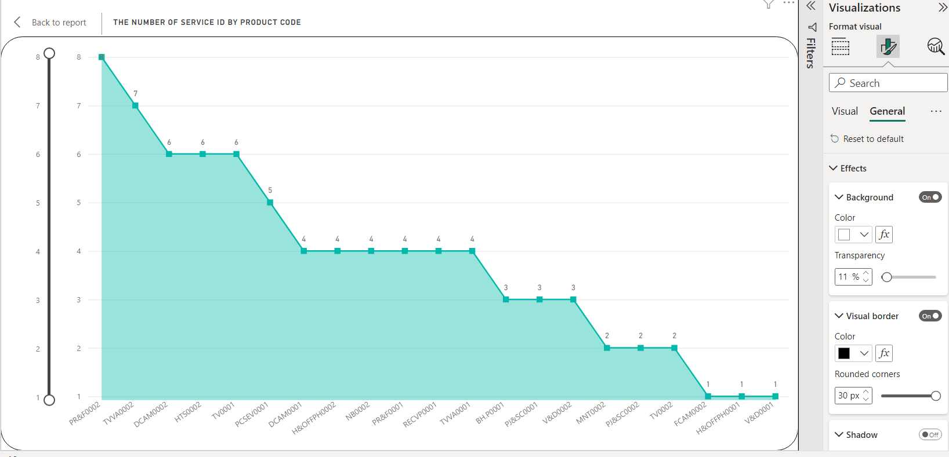

Fig (3.)

In this case, you can customize the background, visual borders, and shadows to make this pie report noticeable, and this report has been made user friendly for viewers.

### Cluster column Chart of the Number of Order By Year for Strategic Level

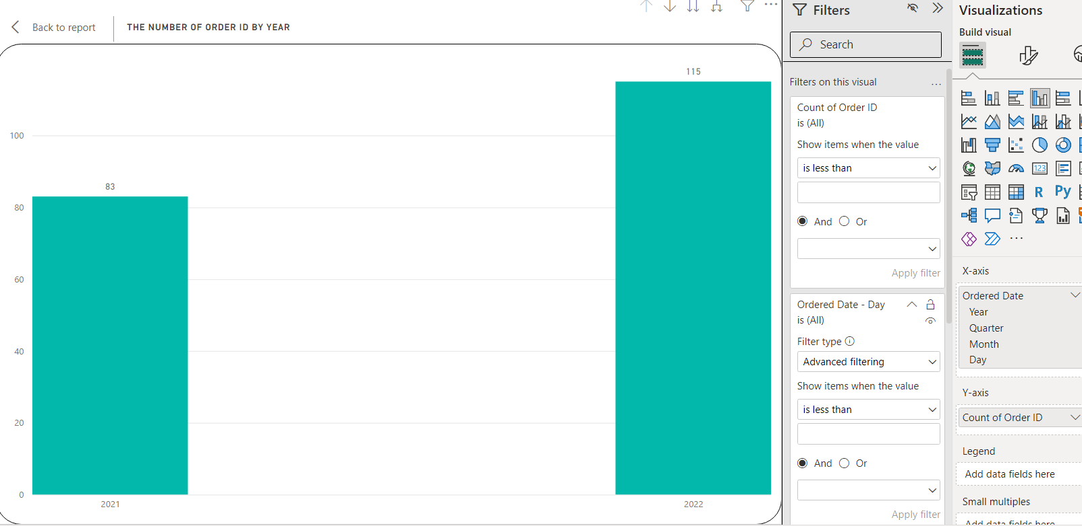

Fig (3.)

In this pie chart, I did the product total sale for each yar. In this figure can see the filters. In this area can do limitation for the total sale and order date that they want to be as a user-friendly.

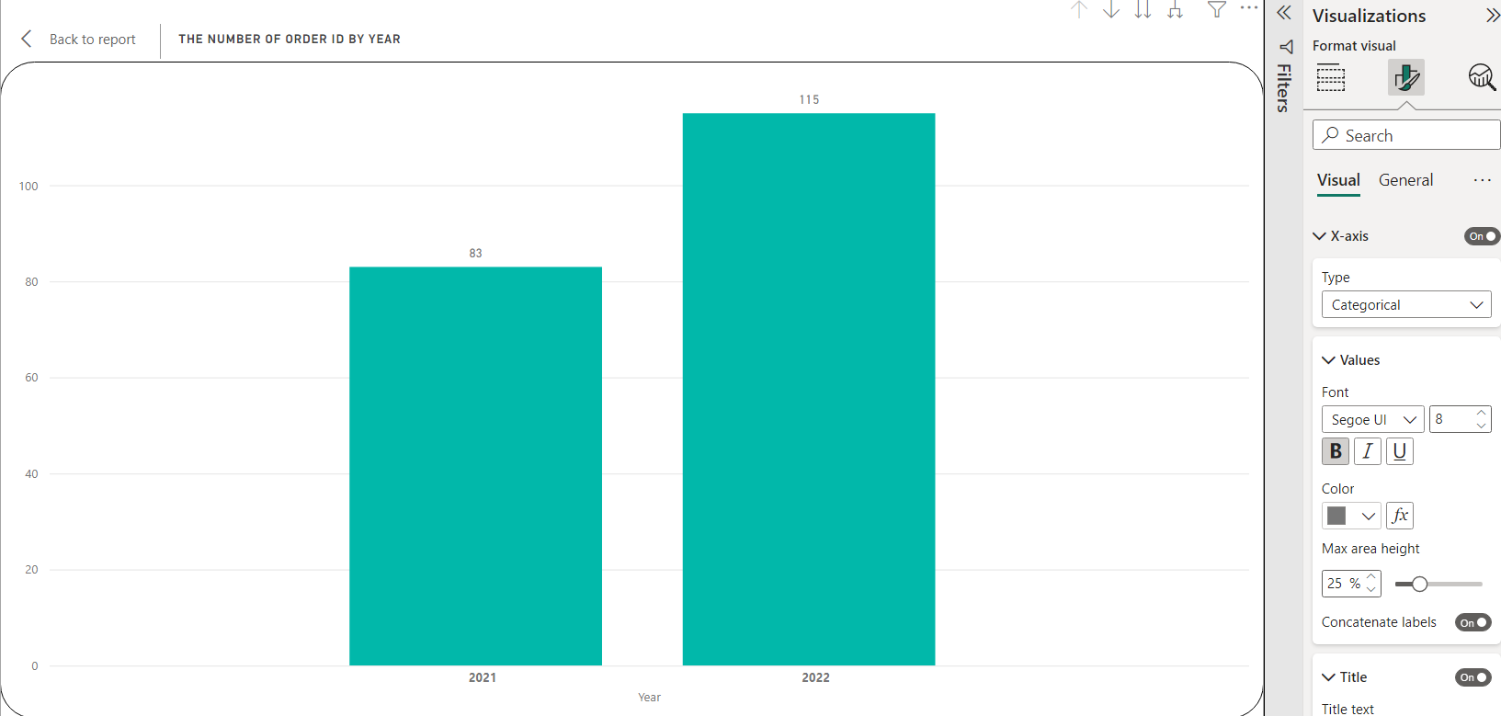

Fig (3.)

In this case, you can customize the data and values ​​in the x-axis to be visible for the users.

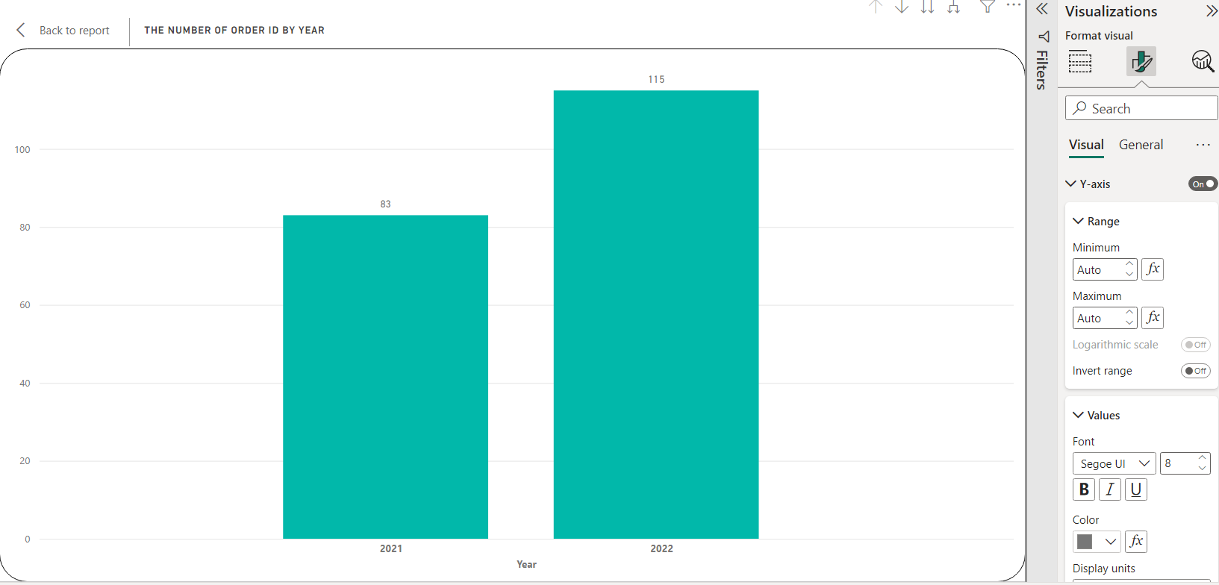

Fig (3.)

In this case, you can customize the data and values ​​in the y-axis to be visible for the users.

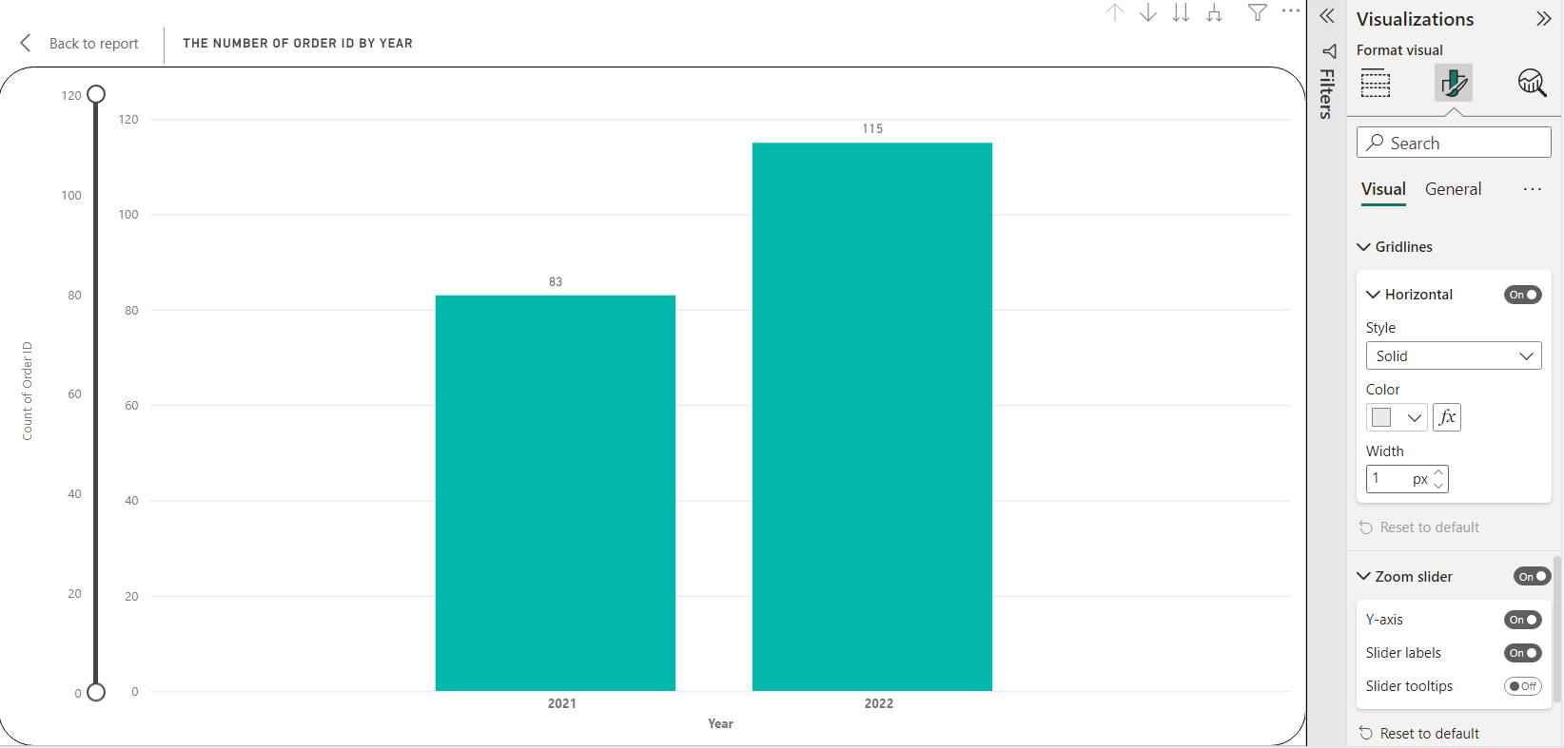

Fig (3.)

In this case customize about the types of horizontal lines and the color and width of horizontal line. And by adding a zoom slicer, it is a customizing that makes it convenient for users to view the report.

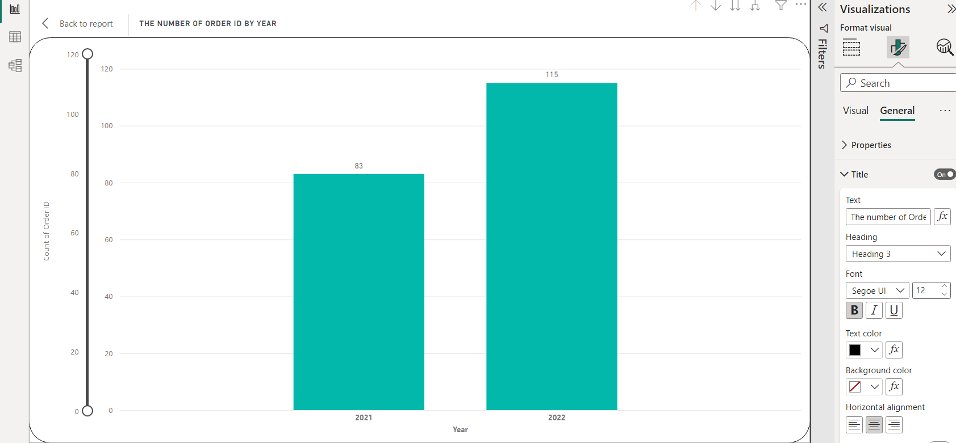

Fig (3.)

This is one of the cases of pie report customization, it is the customized steps to change the titles to the desired form so that it can know clearly what this pie report is.

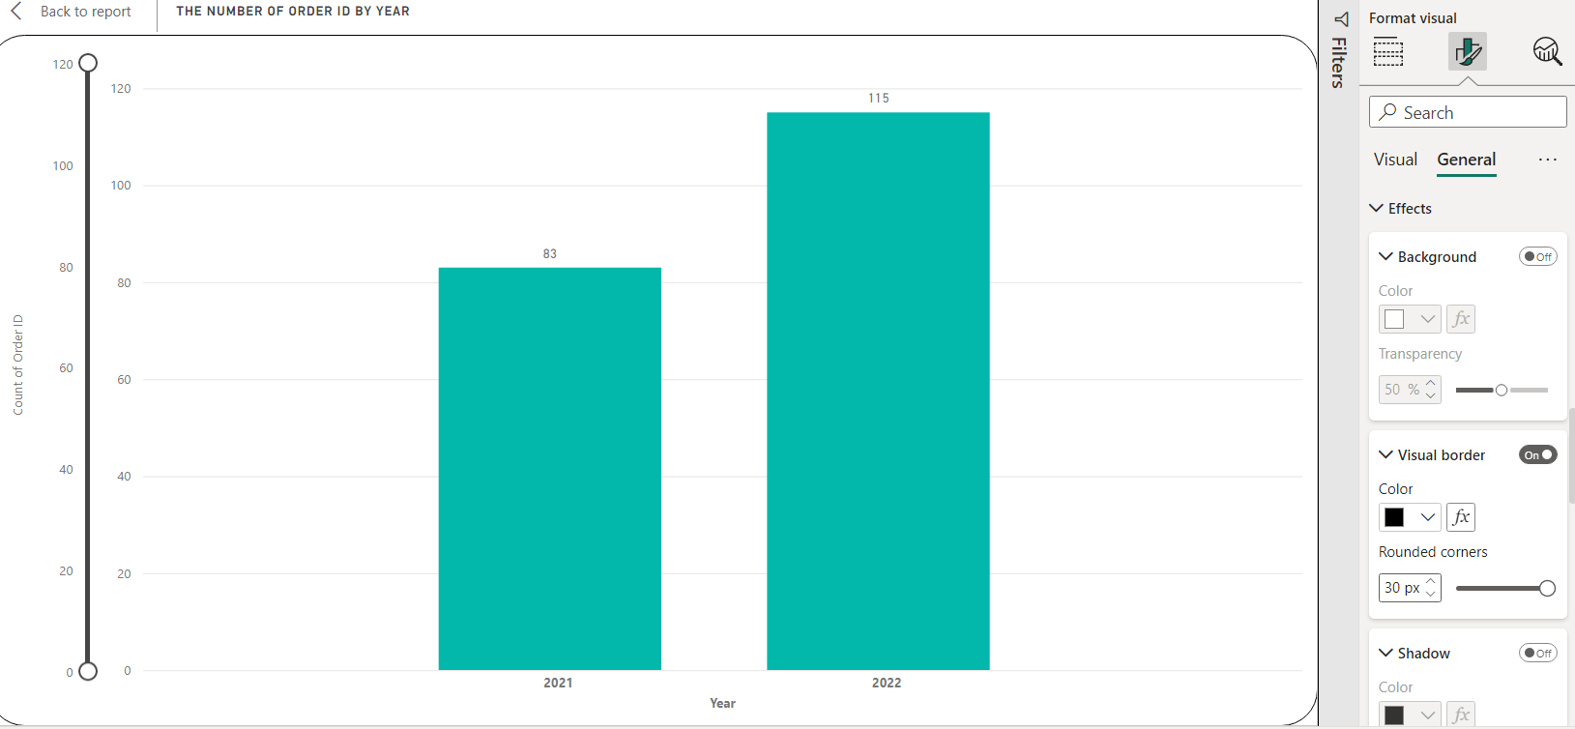

Fig (3.)

In this case, you can customize the background, visual borders, and shadows to make this pie report noticeable, and this report has been made user friendly for viewers.

**Customize of Canvas setting**

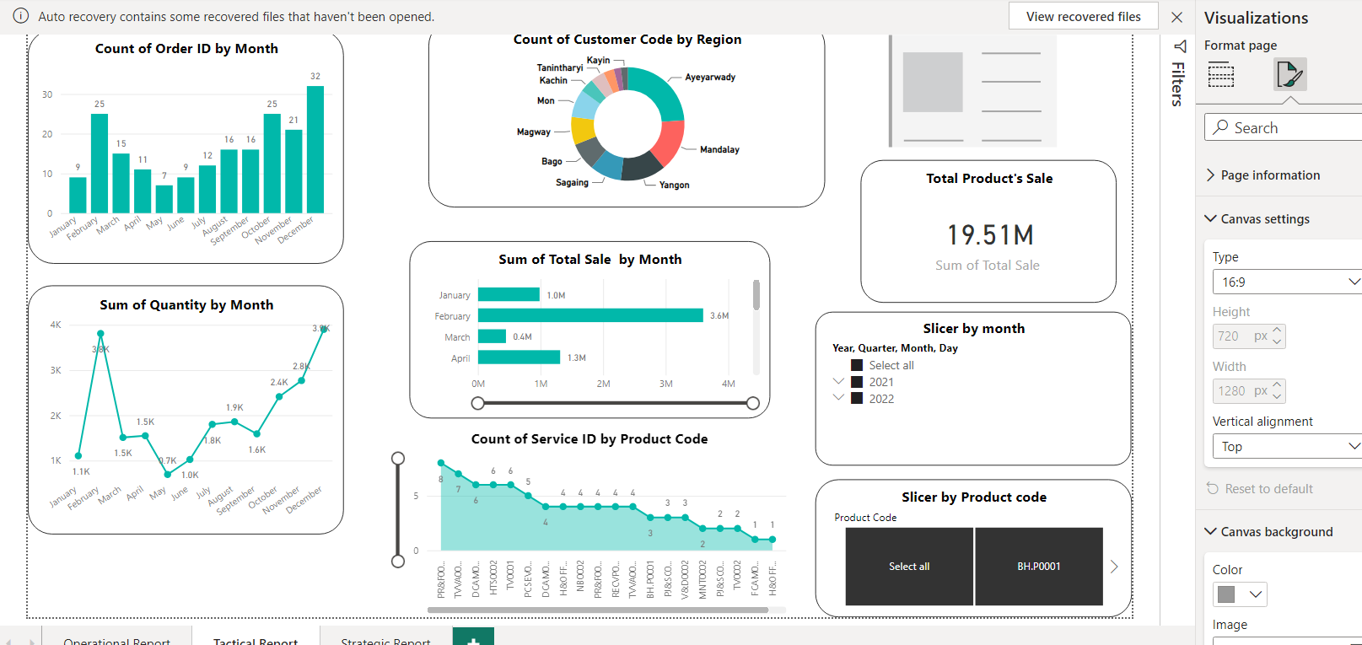

Fig (3.)

In this canvas settings can the size of the whole reports by using height and width. By customizing this things can affect for the users.

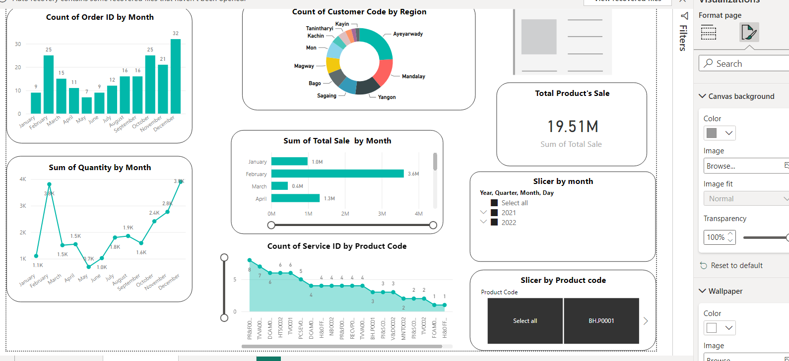

Fig (3.)

This one customize the background color and wallpapers for the whole report. In this case can customized the color and background by comparing with each reports to be perfect reports.

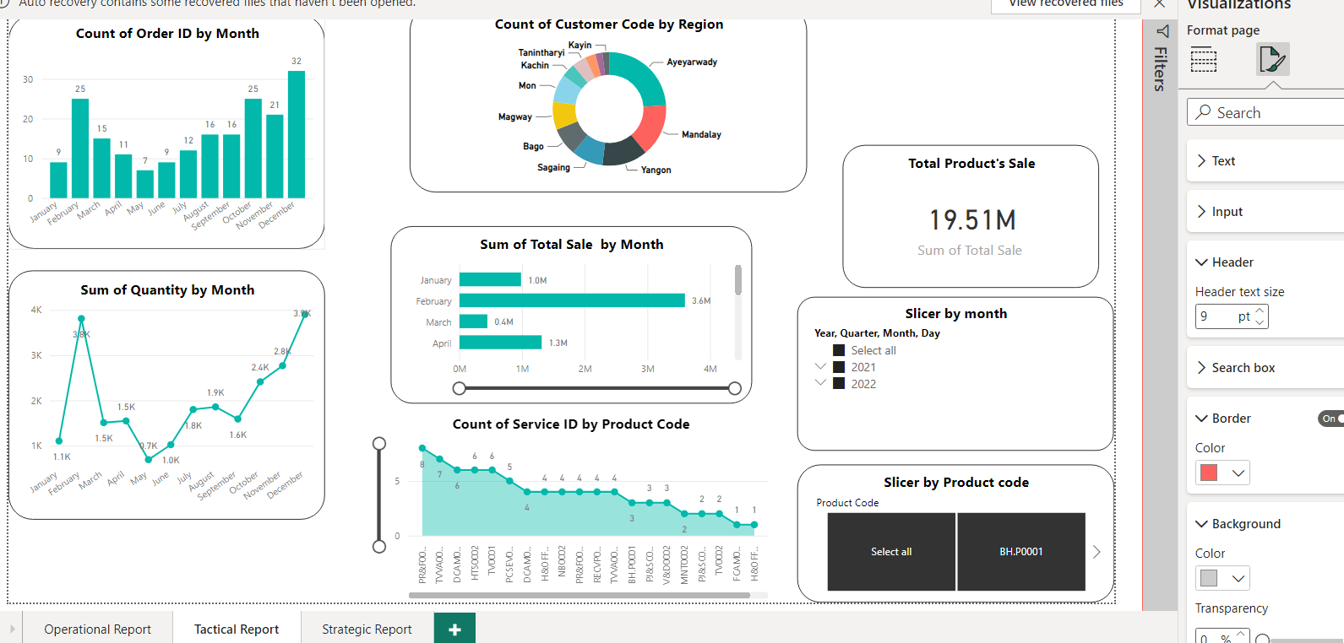

Fig (3.)

This case is customized the color of the borders and outside background by clicking the color buttons.

# LO 4: Discuss the impact of business intelligence tools and technologies for effective decision-making purposes and the legal/regulatory context in which they are used.

## P.5 Discuss how business intelligence tools can contribute to the effective decision-making.

Discuss how business intelligence tools can contribute to the effective decision-making of business process for productivity, extending to wider target audience, more competitive or profitable and improved customer service.

### How Business intelligence tools can contribute to effective decision-making

First of all, the upper three types of ETL from the bi tool must be done first to create other processes. You must extract the data file you have in the extraction process. some of the data can be structured or unstructured data. You can transform and convert unstructured data into correct data. And then, you can add other calculations and data types that you want can be changed in a systematic power query. So that correct information can be obtained from correct data and then correct decisions can be made for the organization. That was the transforming process. After that click the apply and close you will arrive at the data Wearhouse of the power bi. After that, you will use other process to get the detailed information and correct decisions.

By using the drill-down operation in the in bi tool, you can see detailed information. Therefore, you can know what and where the weakness is. According to our organization, customers submit service forms more often if there is a problem with their devices. In such a situation, we can see which device has an error and where it is by looking at the drill down of the bi tool. And then we know what is the problem and can explain it to get better. Therefore, we can make the right decisions, get better satisfaction from customers, and improve customer service. For that reason, Bi tools are effective for making decisions.

The second piece of advice was that to Make Effective Decisions, the organization need to have a quick overview of company's operational and financial situation. For those procedures, bi tools can be used. Using various tools, their company can swiftly prepare the report to get a general idea of the product selling rate and order rate. Then, they will be able to identify the best- and worst-selling products. So that they can decide which product to promote and how to market to sell out, as well as which products have to fill additional stock of. Thus, BI tools and techniques are useful for decision making of the organization.

Some of stock must be dead stock. Stock that has been on the shelf for so long that it can no longer be sold or returned is known as dead stock. Dead stock can result from a product losing customers or from the release of newer models of the product, rendering your stock obsolete. Stock that has really died can sometimes be referred to as dead stock. Dead stock not only wastes warehouse space that might be used for profitable items, but also results in a loss of investment money. At that time, you can solve this problem by using bi tools. In most organization, people can see clearly the overview of each departments and can matched the stock of product and the trend product. And then they can make a decision, on how to sell our dead product, not be a dead stock and then how to get the money back from it. Therefore, Business intelligence tools can contribute to effective decision-making.

By monitoring the overview of sale’s report, sales managers can immediately determine which clients are making purchases and, more crucially, which goods are losing popularity. By tracking client purchases on a daily, weekly, monthly, or annual basis, business intelligence (BI) enables you to instantly visualize consumer spending trends. Finding these tendencies reveals newer sales opportunities. By looking at the annual sale rate, we can see how much profit and how much loss the company has in a competitive way.

## P6.Explore the legal issues involved in the secure exploitation of business intelligence tools.

Explore the legal issues involved in the secure exploitation of business intelligence tools of business process.

Business intelligence (BI) has always been a vital tool for law firms and one that largely fulfills the functions of the firm's library and analysis. Historically, BI has been used to record a moment in time and release static information on many issues such as consumers, markets, and lawyers through packaged reports, dashboard-based information displays, and data analysis. As business and legal needs become more sophisticated, BI's present roles range from providing market statistics to making judgments, looking back on the past, and keeping track of goals. As we do business online, e-commerce is evolving fast, and businesses are working to adapt.

The BI tools of the business process need to do security for the organization. So, we have to need to produce three levels of business reports. In this report, we need to put the permissions for each level report. The strategic level can see all the reports of the organization. Because they have to do the main decision for the organizations and then need to control and give the plans for what they want to do for the improvement to the under-level as tactical level and operational level. And then the tactical level can also view the reports from the operational level. Because they also need to review and do some decisions by viewing operational levels. But the operational level can view their only view need to do the process by establishing from the tactical and strategic levels. Those levels had to do permission for each level. Some of the data need to do secret by the organization to protect the adapting information from other companies and organizations.

When we’re using the Power BI desktop of Microsoft, we can share the people of the same domain and same organization. Sharing is the easiest way to give people access to our reports and dashboards in the Power BI service. This report can share with people inside or outside of the organization. Sharing a report or dashboard to the people who can view it and interact with it, but can't edit it. The recipients see the same data on the reports and dashboards. The owner shares the report with the people and they can reshare it with their coworkers if the owner allows them to.

For the business that need to do own laws for the organization. The first one is the organization need to do their own patent for the organization name and their products to the relatable government’s organization. When the one organization start their business, they have to do the contract laws with each employees and cooperative organizations and groups. For example, if one of the employee of the organization sold the inner information to the other organization, the organization can take action with the laws.

## M4.Conduct the research to identify the specific examples of organizations that have used business intelligence tools to enhance or improve operations.

### Real-World Examples of Business Intelligence at Work

Fast and data-driven decision-making can be effective.. Numerous businesses, regardless of size or industry, turn to business intelligence (BI) to gain a competitive edge due to high client expectations, worldwide competition, and tight profit margins. Business intelligence uses include customizing ads based on browser history, giving all employees access to contextual KPI data, and consolidating data from various business units into a single digital ecosystem so that business processes can be more thoroughly examined. Here are some case studies that demonstrate how BI is benefiting businesses all across the world:

### Lotte.com: BI Increases Company Revenue

With 13 million customers, Lotte.com is the top online mall in Korea. The challenge of this company is company executives wanted to know why consumers abandoned their shopping carts given that the site receives more than 1 million hits each day. The solution is that customer experience analytics was the first online behavioral analysis system used in Korea, and it was implemented by the assistant general manager of the marketing planning team. The manager made use of the data to modify the website, perform targeted marketing, and understand consumer behavior. And then the result is that after a year, there was an increase in customer loyalty because of the new BI analytics program, and sales increased by $10 million. The modifications resulted from analyzing the reasons why shopping carts are abandoned like a pointed checkout procedure and unanticipated delivery times—and resolving the issue.



### Reddit

Reddit is a social media platform that specializes on news aggregation and online community interaction. It presently comes in at number seven on Alexa's ranking of the top US websites, and business intelligence is what allows it to monetize that traffic.

Reddit has a lot of data to manage with over 430 monthly visitors from all over the world. The data team used to be entrusted with finishing ad hoc requests, which not only took time away from their own projects but also complicated access to data for other teams. The seventh-most-visited site in the US was unable to fully take advantage of the monetization prospects due to this bottleneck, which also masked promising insights. Reddit didn't intend for everyone to use its business intelligence tool, but since Charito was so user-friendly, they started getting requests from staff members to run their own data queries. In the end, a culture of data democracy similar to Data Robot emerged through "grassroots" initiatives.

The sales team became some of the greatest BI aficionados once they granted access to the rest of the organization. They used it to analyze Reddit's enormous data set in real time to discover when brands or items were discussed among the 2-million+ communities. They produce graphs and visualizations demonstrating how companies may accede to the daily discussions taking place on Reddit using Charito and Google Big Query.

If the backlog had continued, this kind of understanding would never have emerged. Without a culture of data democracy, it also would not have taken place. Reddit data scientist Justin Bassett observes that "Sales have surged considerably" and that "More users are making discoveries and revealing solutions they couldn't have gotten on their own before."



### Coca-Cola Bottling Company maximized operational efficiency

The problem of the Coca-Cola is the Manual reporting processes restricted access to real-time sales and operations data. The business intelligence unit of Coca-Cola manages reporting for all of the company's delivery and sales activities. The team simplified manual reporting procedures using its BI platform, saving over 260 hours annually—more than six 40-hour work weeks. Mobile dashboards that offer timely, useful information and a distinct competitive edge put customer relationship management (CRM) data back into the hands of sales people in the field through report automation and other enterprise system interfaces. Self-service BI implementations encourage more productive IT and business user partnerships that make the most of participants' knowledge. Instead of doing manual research and reporting, analysts and IT may concentrate on long-term breakthroughs like enterprise data governance and big-picture strategy.



# References

Select hub [Online] Available From:

https://www.selecthub.com/business-intelligence/key-types-business-intelligence-tools/ [Accessed: 25.11.22]

Tech Target [Online] Available From:

https://www.techtarget.com/searchcio/definition/business-process-management

[Accessed: 27.11.22]

Puget Systems [Online] Available From:

https://www.pugetsystems.com/labs/articles/Top-10-things-you-should-be-doing-to-maintain-your-computer-39/

[Accessed: 29.11.22]

Money Crashers [Online] Available From:

https://www.moneycrashers.com/computer-maintenance-tips-checklist/

[Accessed: 29.11.22]

Puget Systems [Online] Available From:

https://www.pugetsystems.com/labs/articles/Top-10-things-you-should-be-doing-to-maintain-your-computer-39/

[Accessed: 1.12.22]

Coursera [Online] Available From:

https://www.coursera.org/articles/bi-tools

[Accessed: 5.12.22]

Puget Systems [Online] Available From:

<https://www.techtarget.com/searchbusinessanalytics/definition/business-intelligence-BI>

[Accessed: 8.12.22]

Puget Systems [Online] Available From:

<https://www.stitchdata.com/resources/7-reasons-power-bi/>

[Accessed: 9.12.22]

Puget Systems [Online] Available From:

<https://www.netsuite.com/portal/resource/articles/business-strategy/business-intelligence-examples.shtml>

[Accessed: 9.12.22]

Puget Systems [Online] Available From:

<https://www.cio.com/article/272364/business-intelligence-definition-and-solutions.html>

[Accessed: 10.12.22]

Puget Systems [Online] Available From:

<https://www.selecthub.com/business-intelligence/key-types-business-intelligence-tools/> [Accessed: 11.12.22]

Puget Systems [Online] Available From:

<https://www.techtarget.com/searchbusinessanalytics/definition/business-intelligence-BI>

[Accessed: 12.12.22]